**Contributor name:** Debatosh Chakraborty

**Book Proposed:** Mathematical Statistics and Data Analysis

**Total Chapters:** 14

**Total Examples:** 252

**Codable Examples:** 117

**Chapter 1: Probability**

Example 1.2.A – Non-Codable (Reason: Theoretical example of finding sample space)

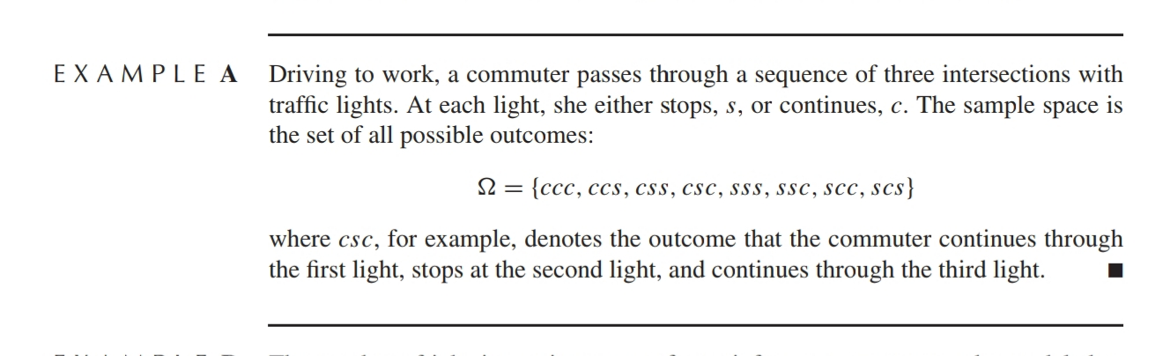

Example 1.2.B – Non-Codable (Reason: Theoretical example of finding sample space)

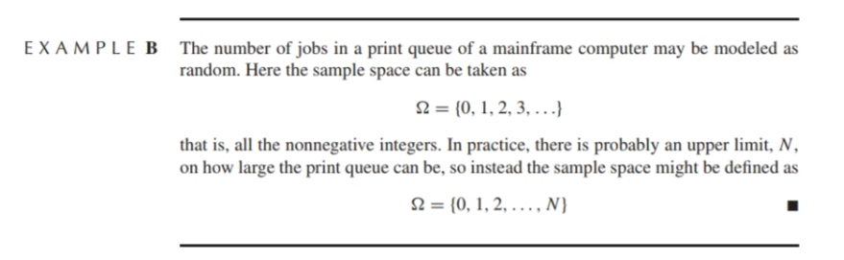

Example 1.2.C – Non-Codable (Reason: Theoretical example of finding sample space)

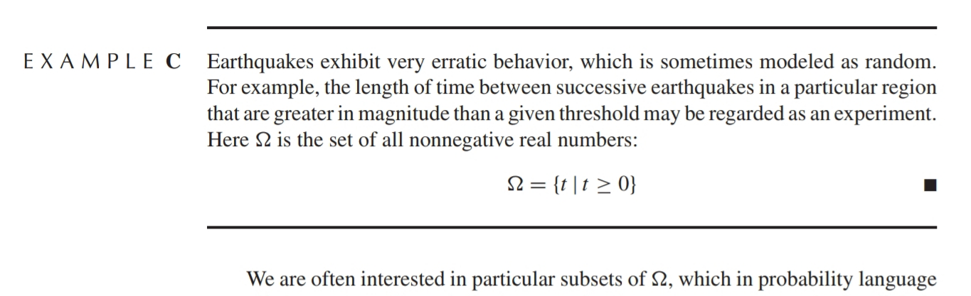

Example 1.3.A – Codable

Example 1.3.B – Codable

Example 1.4.A – Codable

Example 1.4.B – Codable

Example 1.4.1.A – Codable

Example 1.4.1.B – Codable

Example 1.4.1.C – Codable

Example 1.4.1.D – Not Codable (Reason: Theoretical demonstration and no computation)

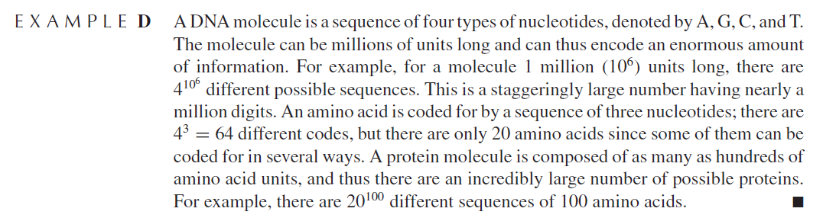

Example 1.4.2.A – Codable

Example 1.4.2.B – Codable

Example 1.4.2.C – Codable

Example 1.4.2.D – Codable

Example 1.4.2.E – Codable

Example 1.4.2.F – Codable

Example 1.4.2.G – Codable

Example 1.4.2.H – Not Codable (Reason: Theoretical example of finding probability expression)

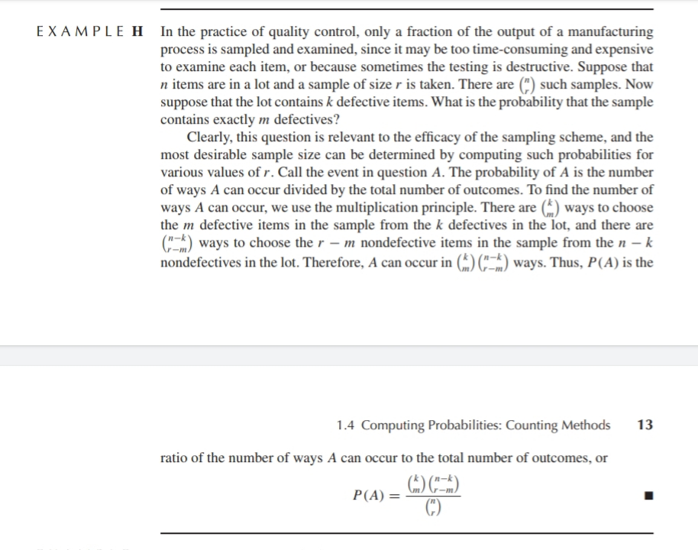

Example 1.4.2.I – Codable

Example 1.4.2.J – Codable

Example 1.4.2.K – Codable

Example 1.4.2.L – Non Codable (Reason: Theoretical example of finding probability expression)

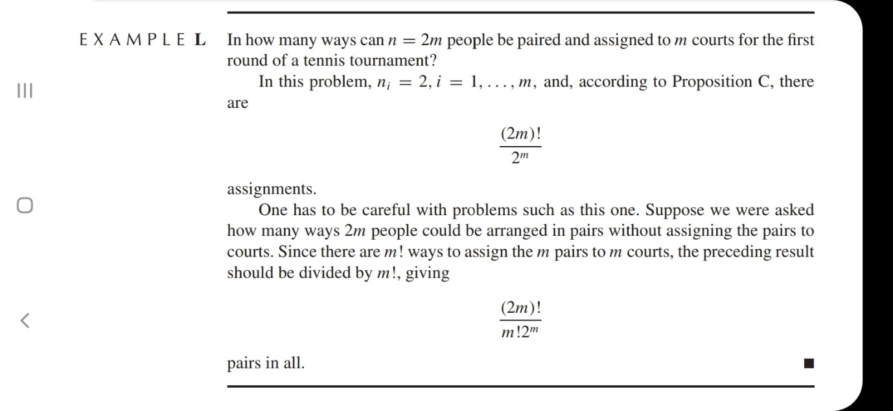

Example 1.5.A – Codable

Example 1.5.B – Codable

Example 1.5.C – Codable

Example 1.5.D – Codable

Example 1.5.E – Codable

Example 1.5.F – Codable

Example 1.6.A – Codable

Example 1.6.B – Not Codable (Reason: Theoretical demonstration and no computation)

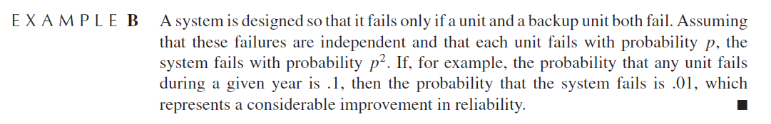

Example 1.6.C – Not Codable (Reason: Theoretical demonstration and no computation)

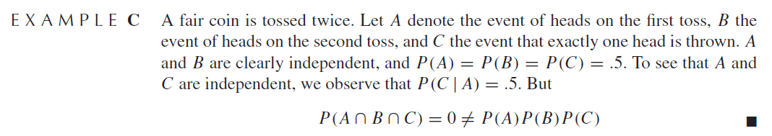

Example 1.6.D – Codable

Example 1.6.E – Not Codable (Reason: Theoretical demonstration and no computation)

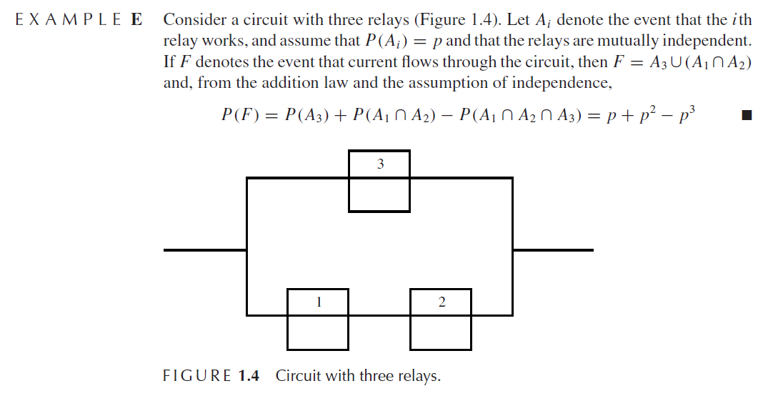

Example 1.6.F – Codable

Example 1.6.G – Not Codable (Reason: Theoretical demonstration and no computation)

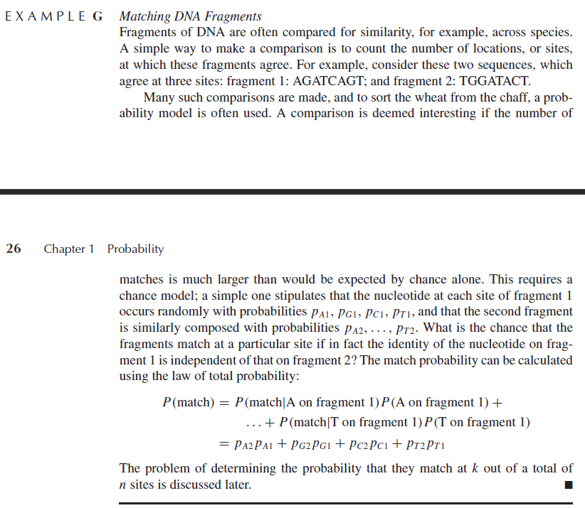

**Chapter 2: Random variables**

Example 2.1.2.A – Codable

Example 2.1.2.B – Codable

Example 2.1.2.C – Not Codable (Reason: Theoretical example of explaining a problem)

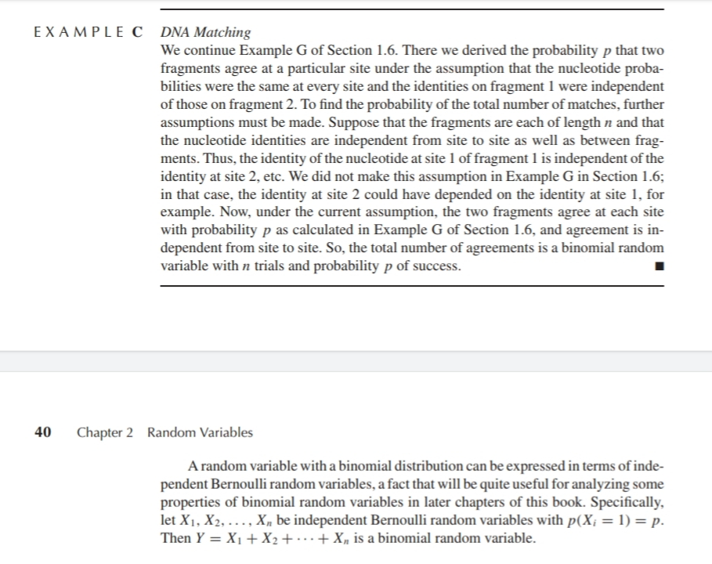

Example 2.1.3.A – Codable

Example 2.1.3.B – Codable

Example 2.1.4.A – Codable

Example 2.1.5.A – Codable

Example 2.1.5.B – Codable

Example 2.1.5.C – Codable

Example 2.1.5.D – Codable

Example 2.2.A – Not Codable (Reason: Theoretical example of introducing a concept)

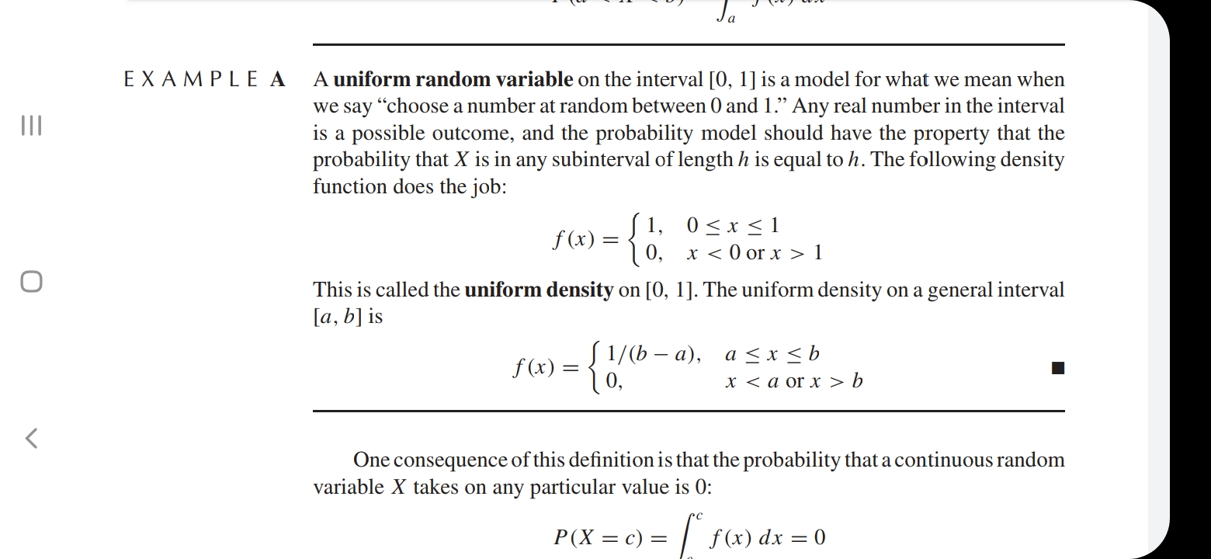

Example 2.2.B – Not Codable (Reason: Theoretical example)

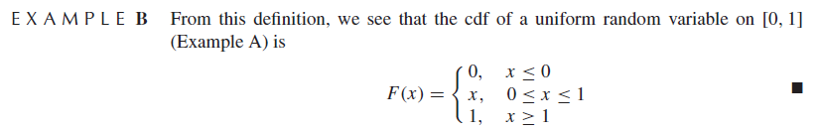

Example 2.2.C – Codable

Example 2.2.D – Not Codable (Reason: Theoretical example of finding probability expression)

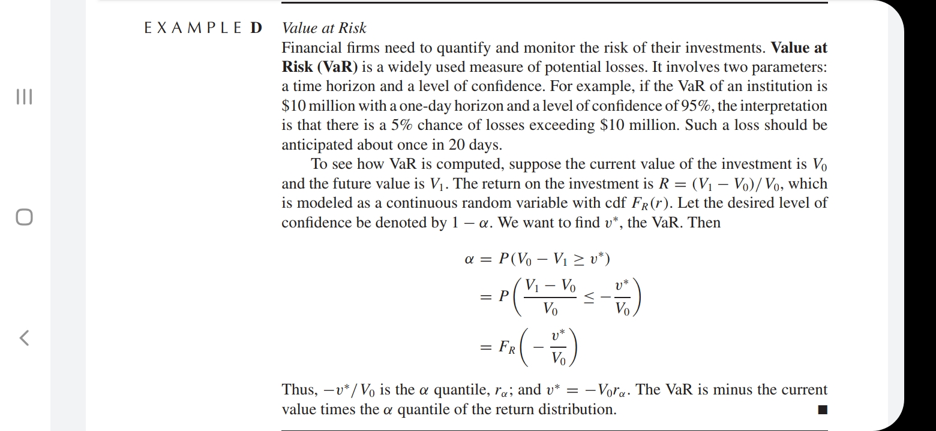

Example 2.2.1.A – Not Codable (Reason: Theoretical example of finding analysis of a particular case study whose data is not available in the book)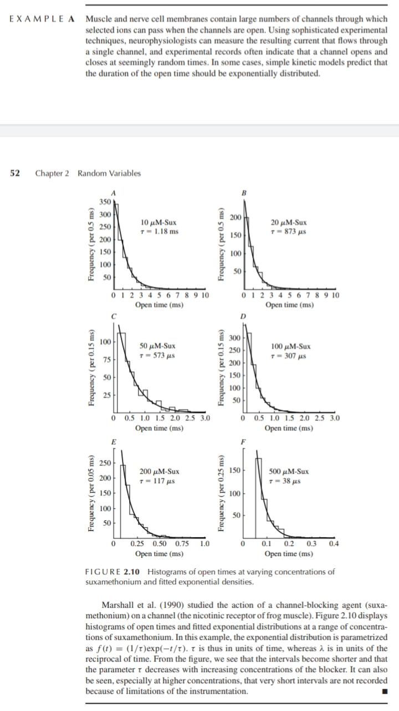

Example 2.2.2.A – Not Codable (Reason: Theoretical example of finding analysis of a particular case study whose data is not available in the book)

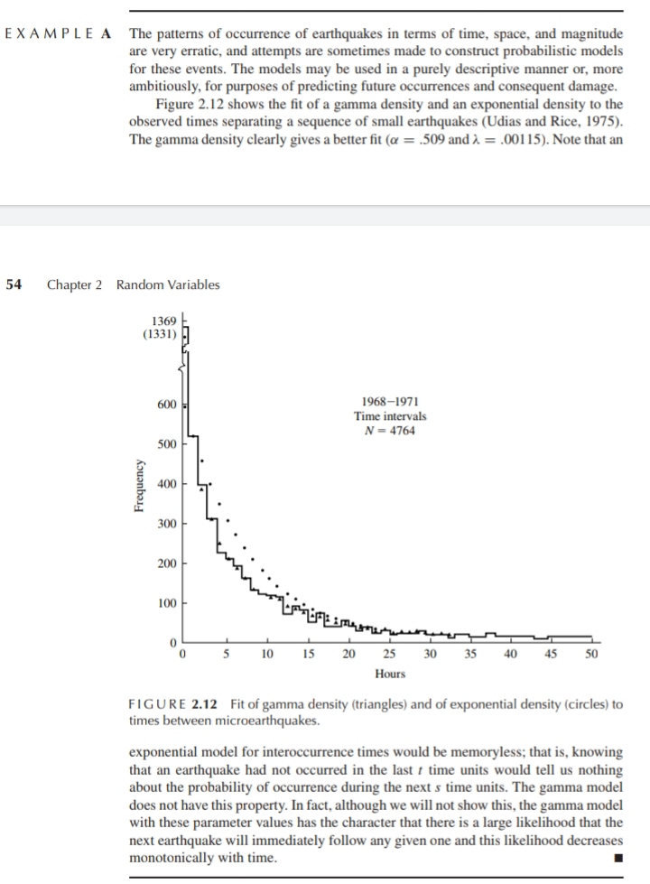

Example 2.2.3.A – Not Codable (Reason: Theoretical example of finding analysis of a particular case study whose data is not available in the book)

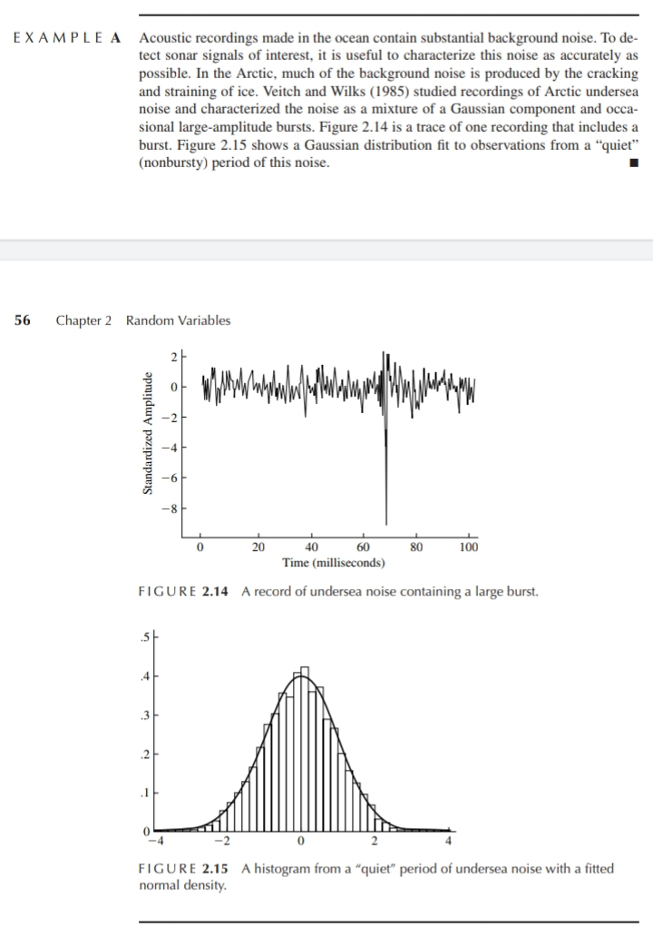

Example 2.2.3.B – Not Codable (Reason: Theoretical example of finding analysis of a particular case study whose data is not available in the book)

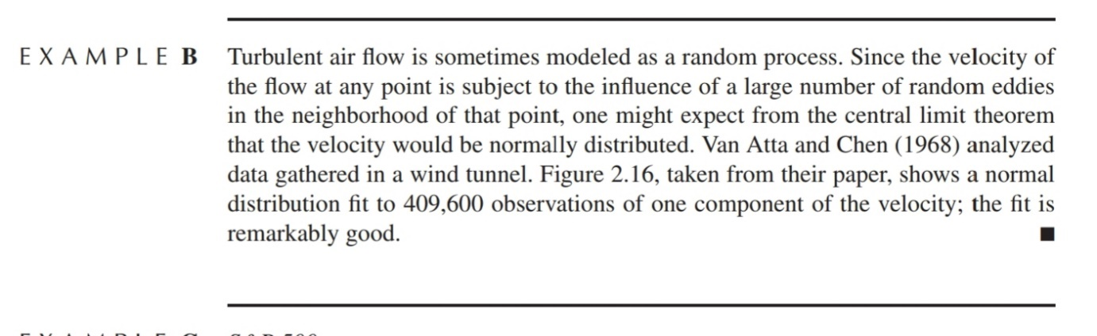

Example 2.2.3.C – Not Codable (Reason: Theoretical example of finding analysis of a particular case study whose data is not available in the book)

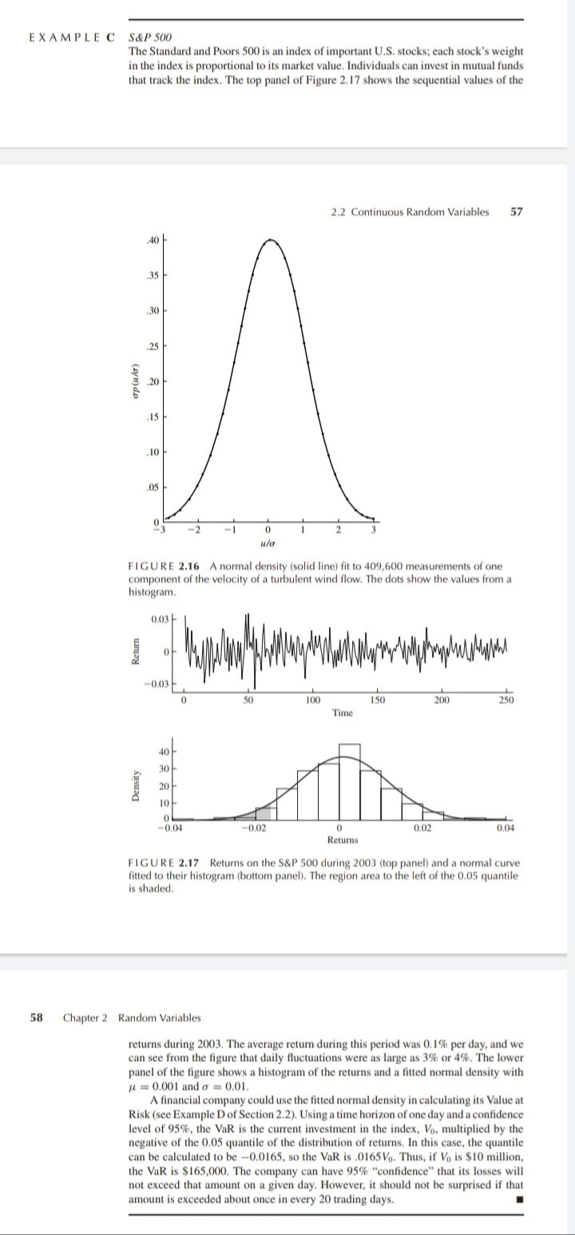



Example 2.3.A – Codable

Example 2.3.B – Codable

Example 2.3.C – Not Codable (Reason: Theoretical example of finding probability expression)

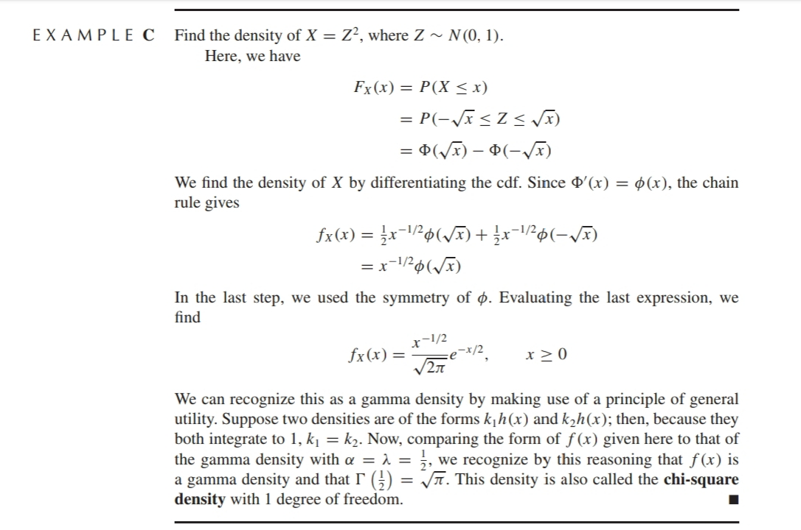

Example 2.3.D – Codable

Example 2.3.E – Not Codable (Reason: Theoretical example of finding probability expression)

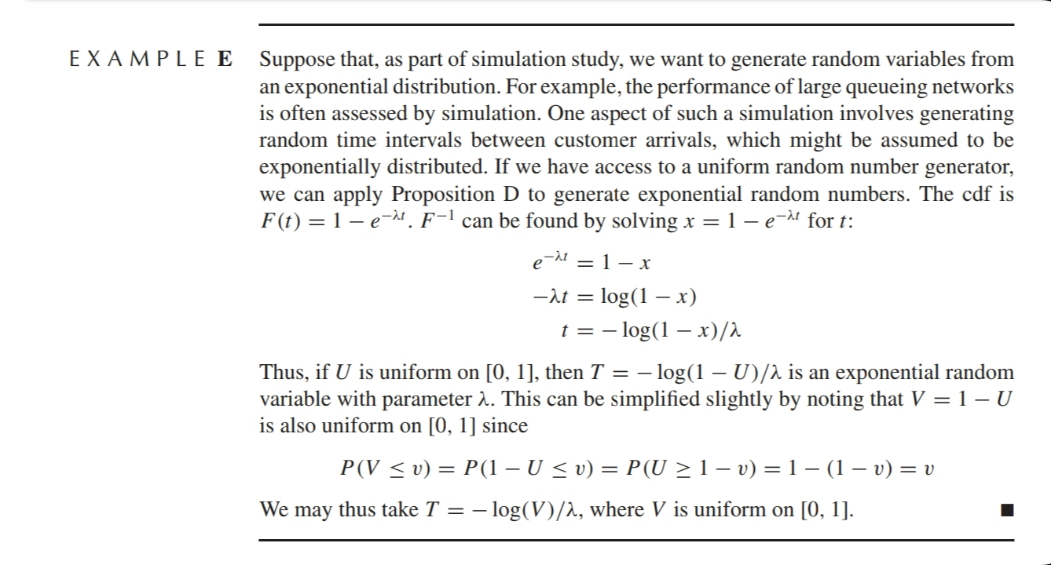

**Chapter 3: Joint Distributions**

Example 3.2.A – Not Codable (Reason: Theoretical example of explaining a concept)

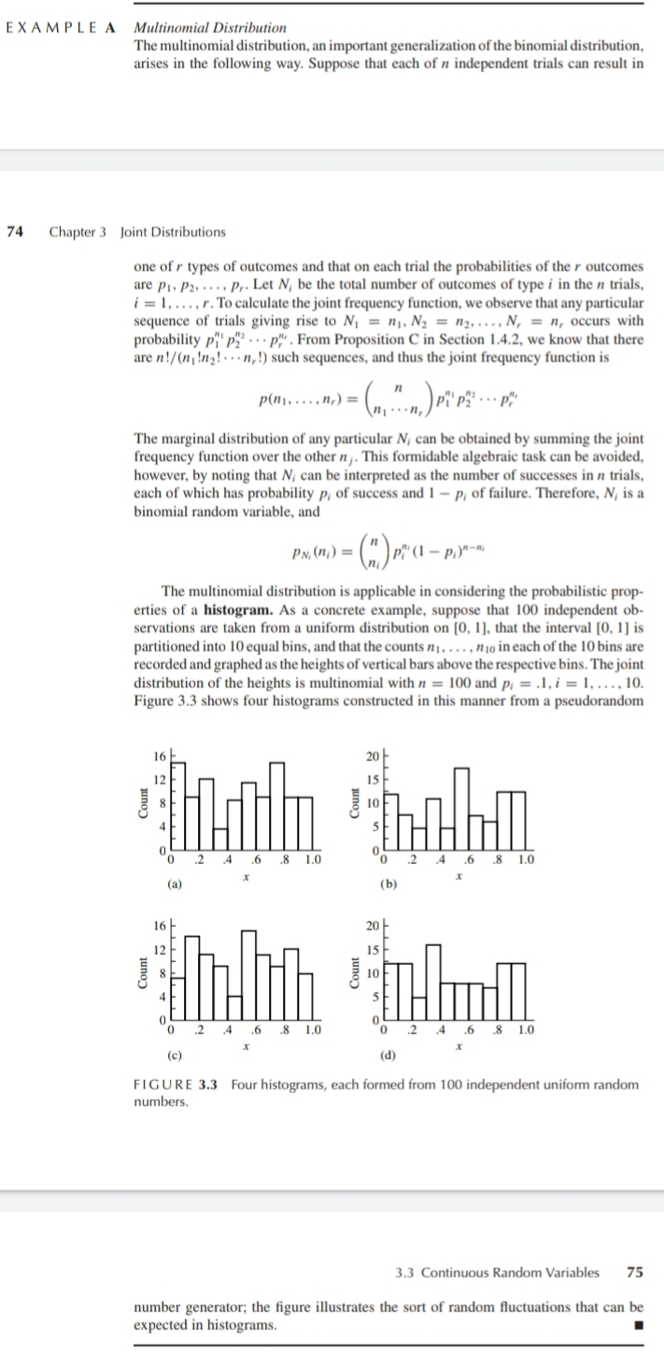

Example 3.3.A – Codable

Example 3.3.B – Codable

Example 3.3.C – Codable

Example 3.3.D – Not Codable (Reason: Theoretical example of explaining a concept and adequate information is absent for plotting)

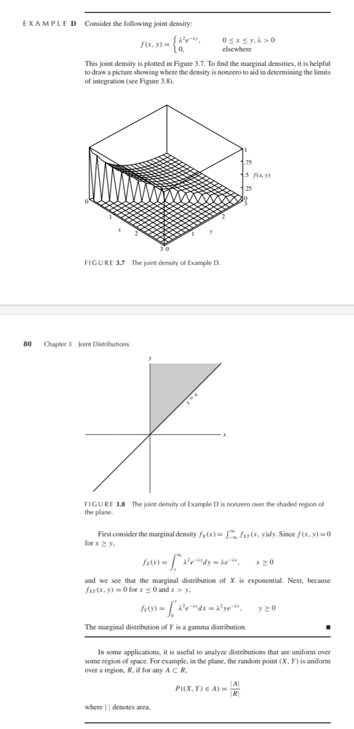

Example 3.3.E – Codable

Example 3.3.F – Not Codable (Reason: Theoretical example of explaining a concept)  
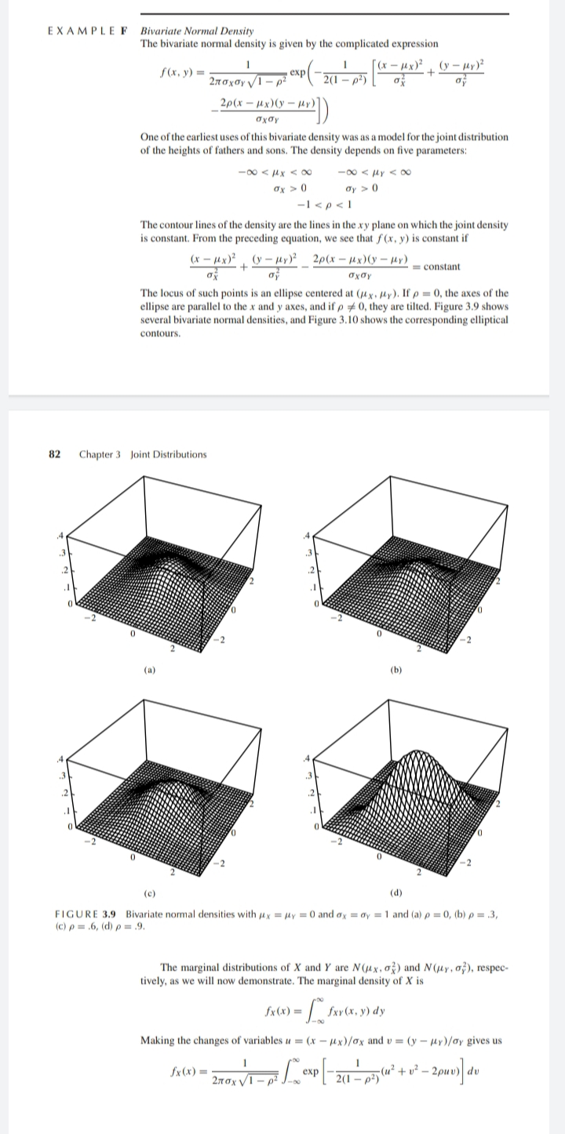

Example 3.4.A – Not Codable (Reason: Theoretical example of explaining a concept)

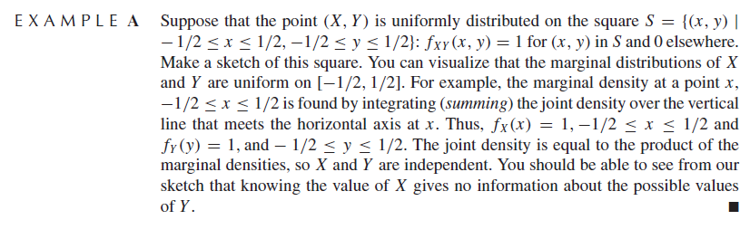

Example 3.4.B – Not Codable (Reason: Theoretical example of explaining a concept)

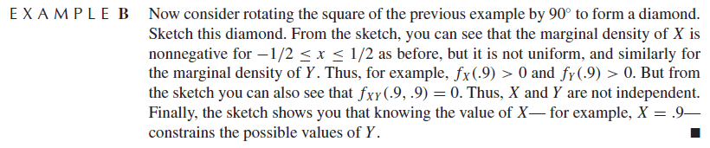

Example 3.4.C – Not Codable (Reason: Theoretical example of explaining a concept)

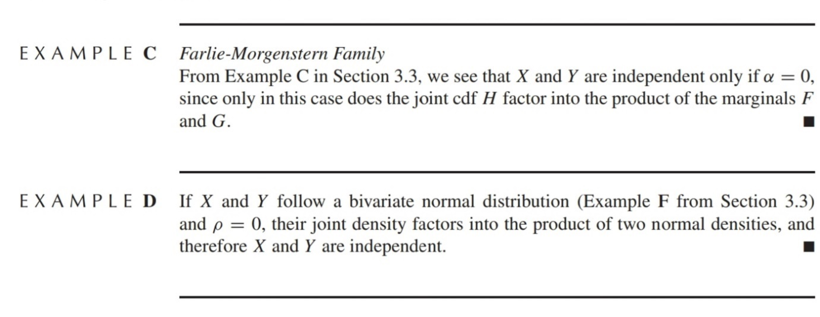

Example 3.4.D – Not Codable (Reason: Theoretical example of explaining a concept)

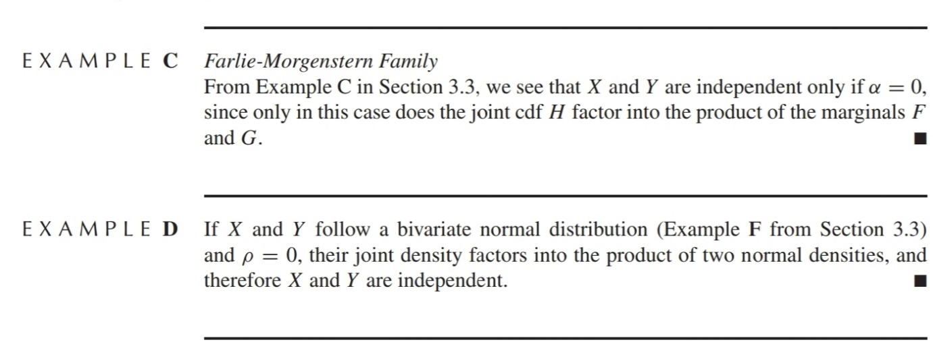

Example 3.4.E – Not Codable (Reason: Theoretical example of explaining a concept)

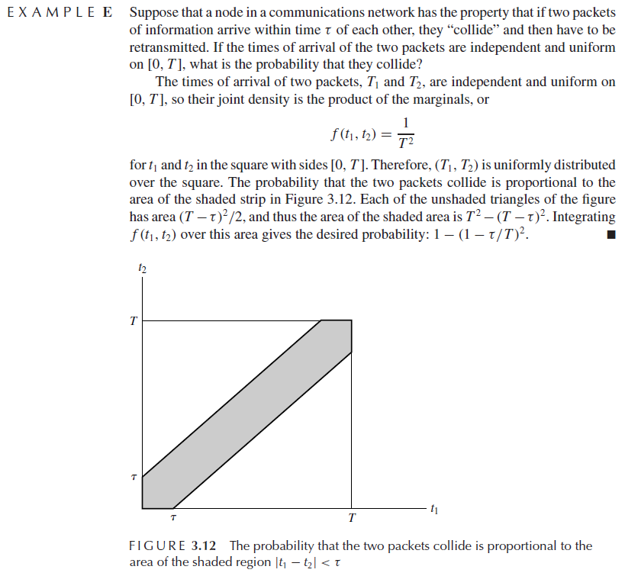

Example 3.5.1.A – Codable

Example 3.5.1.B – Not Codable (Reason: Theoretical example of finding an expression)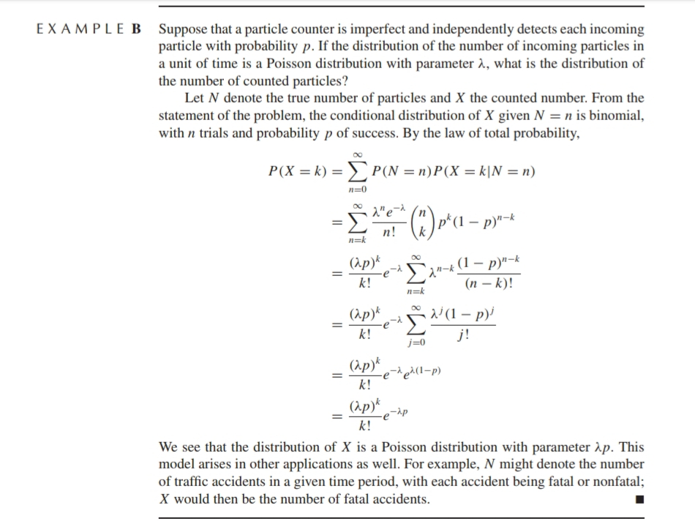

Example 3.5.2.A – Not Codable (Reason: Theoretical example of finding an expression)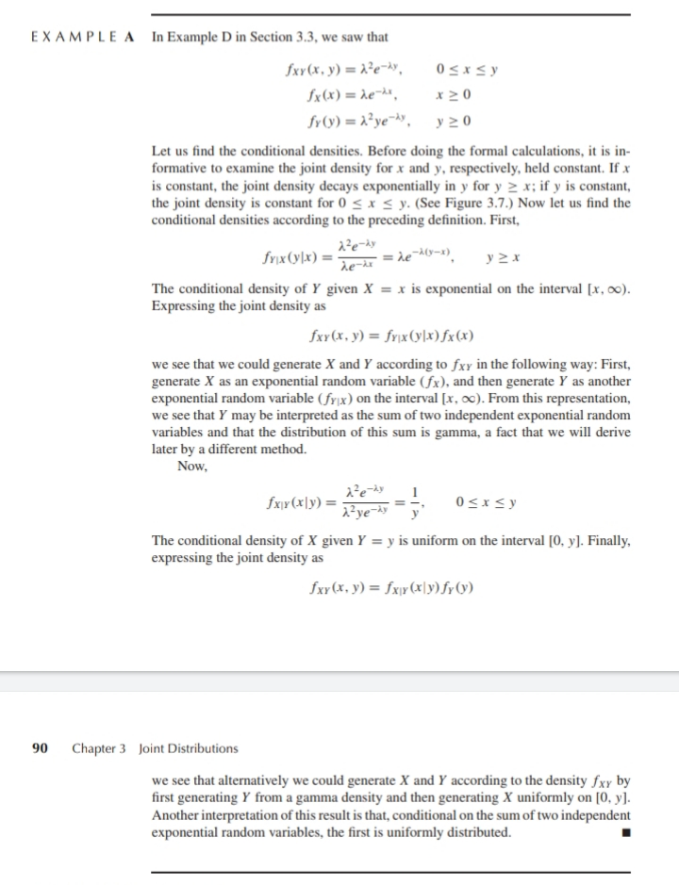

Example 3.5.2.B – Not Codable (Reason: Theoretical example of finding an expression)

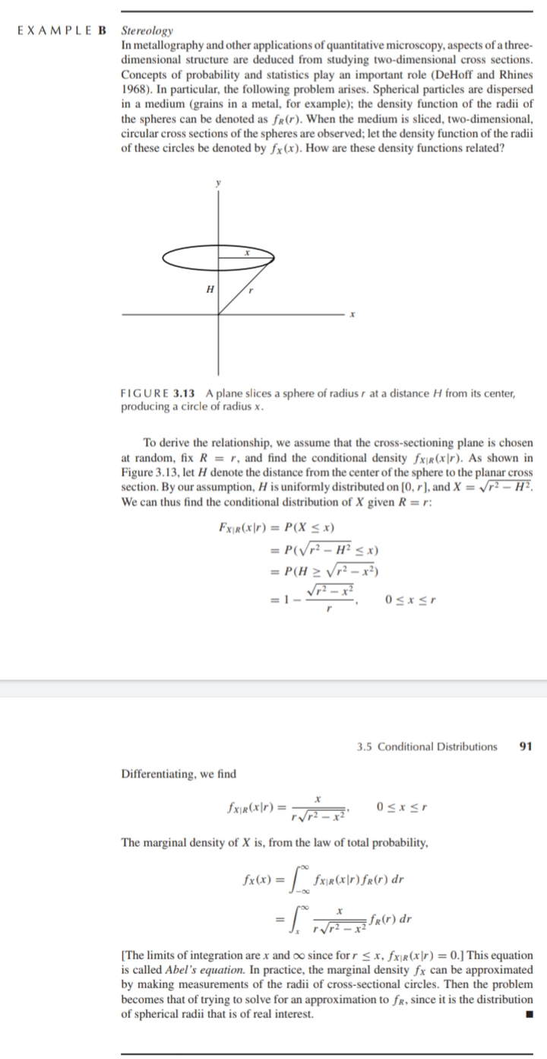

Example 3.5.2.C – Not Codable (Reason: Theoretical example of finding an expression)

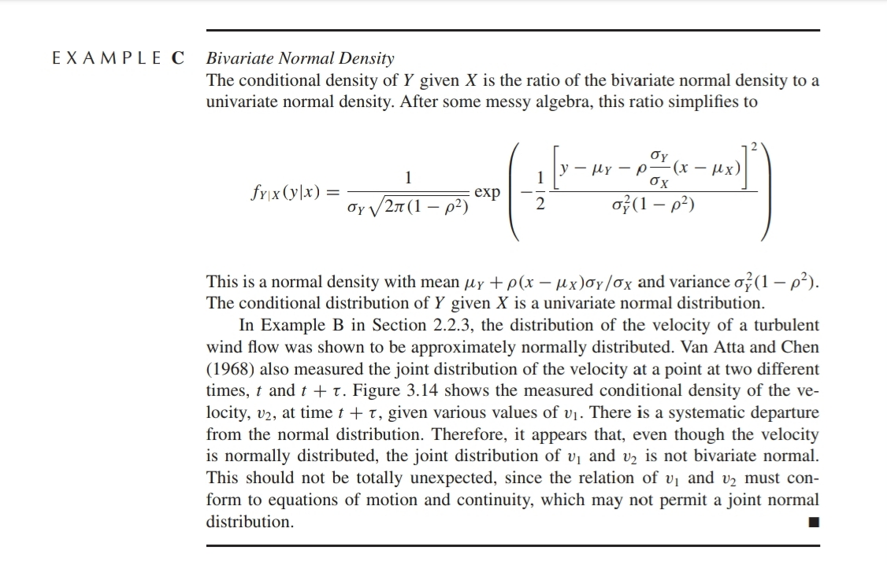

Example 3.5.2.D – Not Codable (Reason: Theoretical example of explaining a concept)  
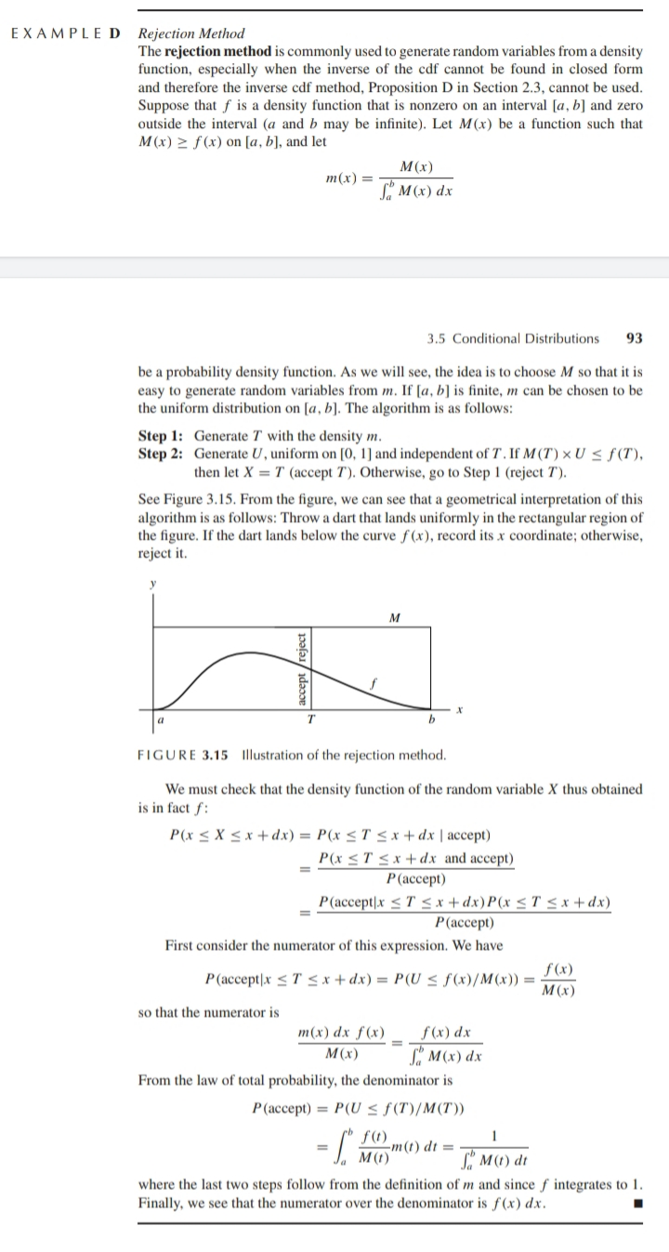

Example 3.5.2.E – Not Codable (Reason: Theoretical example of explaining a concept)

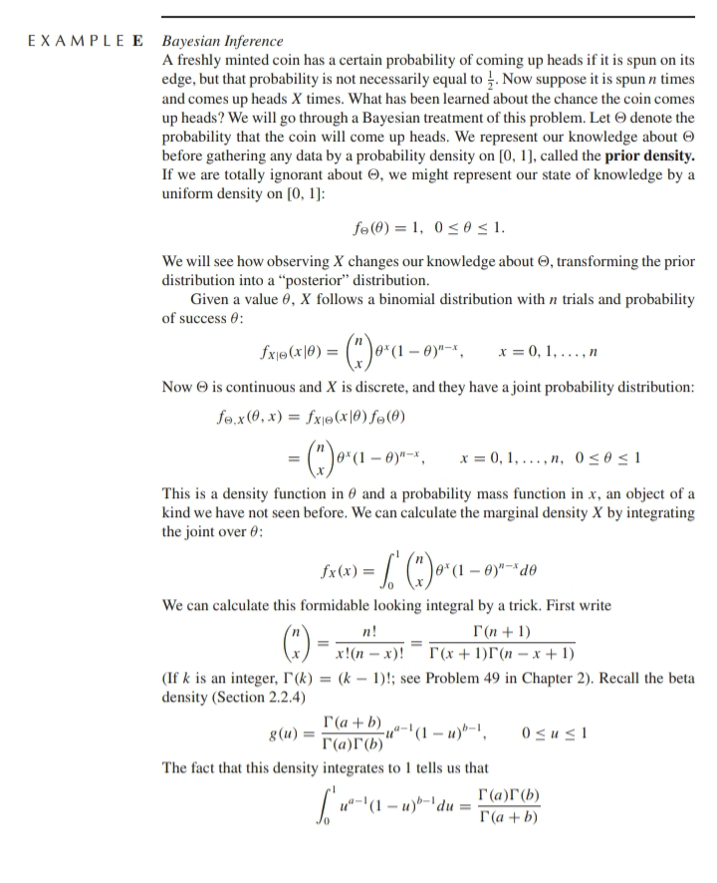

Example 3.6.1.A – Not Codable (Reason: Theoretical example of finding expression)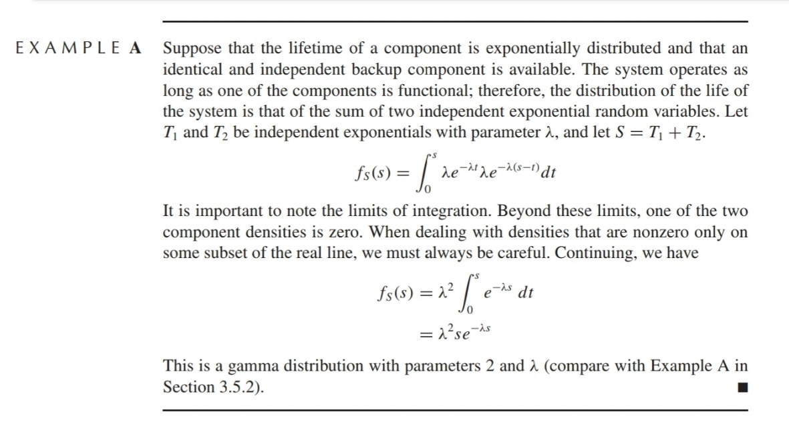

Example 3.6.1.B – Not Codable (Reason: Theoretical example of finding expression)

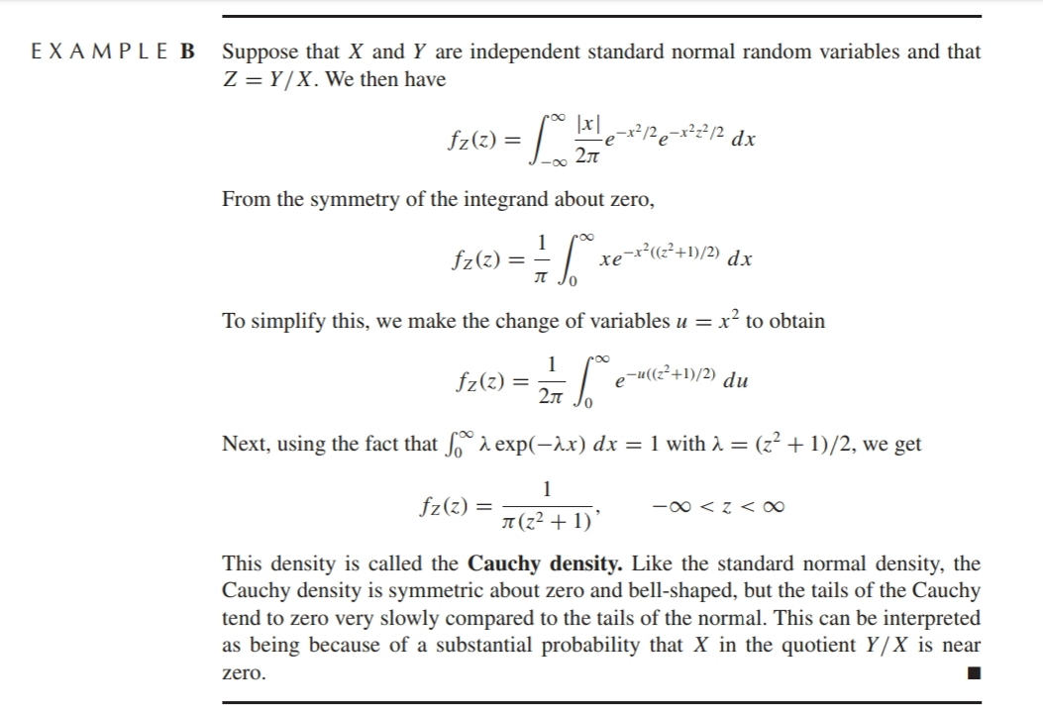

Example 3.6.2.A – Not Codable (Reason: Theoretical example of explaining concept)

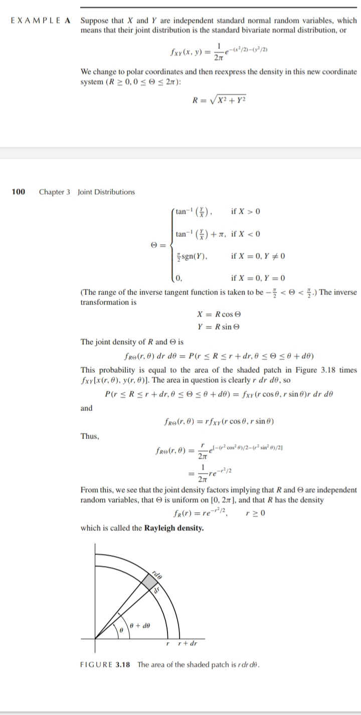

Example 3.6.2.B – Codable

Example 3.6.2.C – Not Codable (Reason: Theoretical example of explaining concept)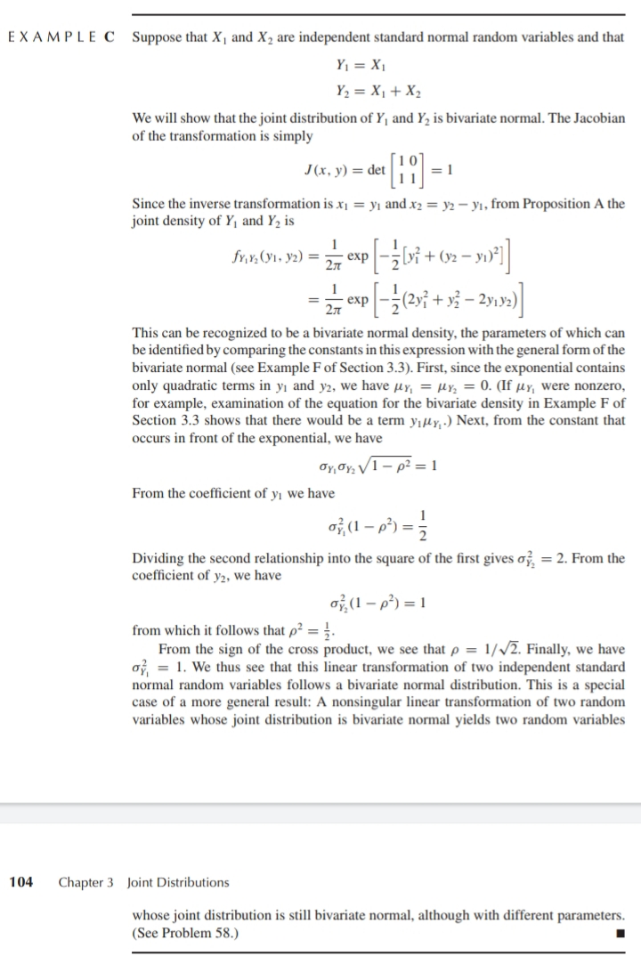

Example 3.7.A – Not Codable (Reason: Theoretical example of explaining concept)

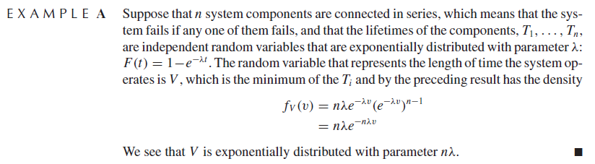

Example 3.7.B – Not Codable (Reason: Theoretical example of explaining concept)

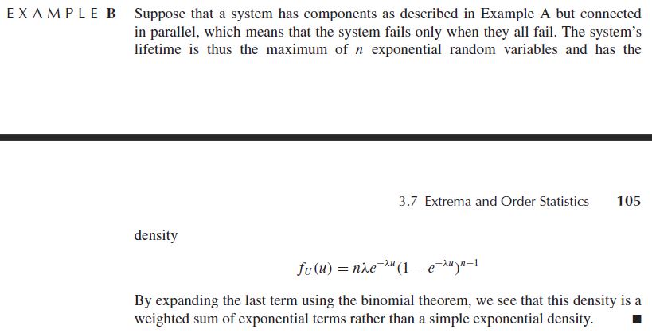

Example 3.7.C – Not Codable (Reason: Theoretical example of explaining concept)

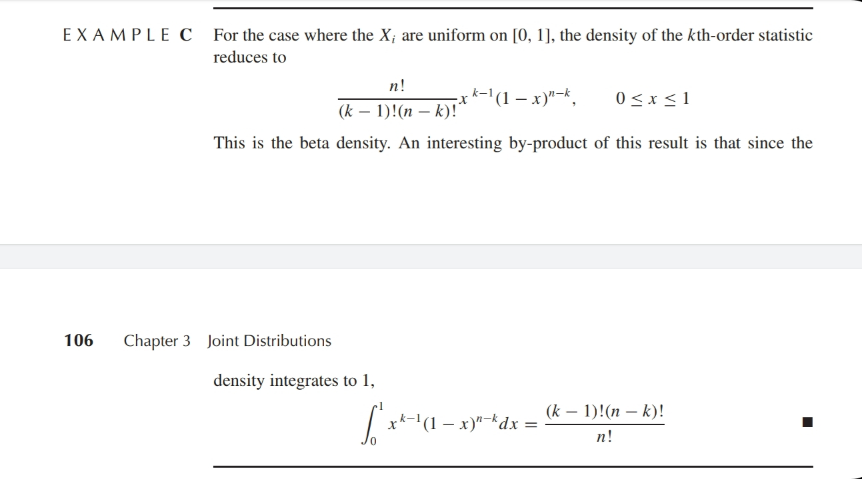

Example 3.7.D – Codable

Example 3.7.E – Codable

**Chapter 4: Expected Values (46, 12)**

Example 4.1.A – Codable

Example 4.1.B – Not Codable (Reason: Theoretical example and not computational)

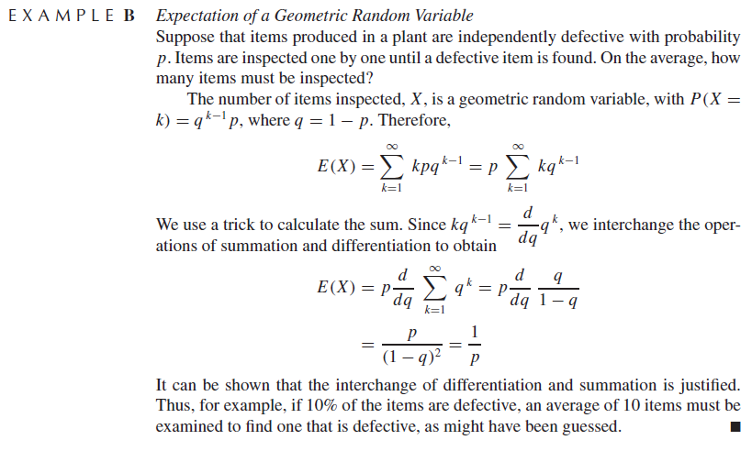

Example 4.1.C – Non Codable (Reason: Theoretical example and not computational)

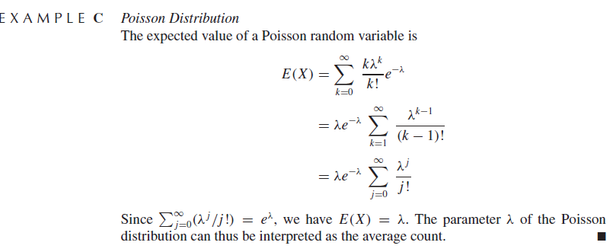

Example 4.1.D – Not Codable (Reason: Theoretical example and not computational)

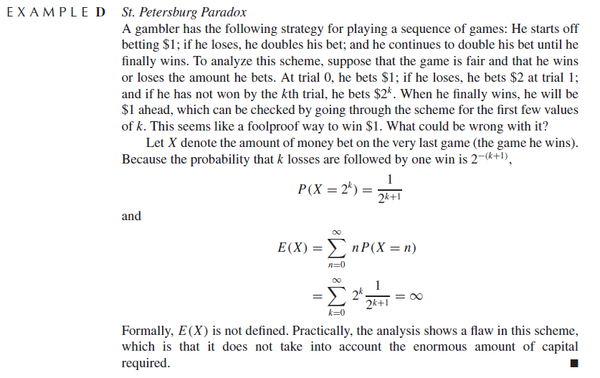

Example 4.1.E – Not Codable (Reason: Theoretical example of explaining concept)

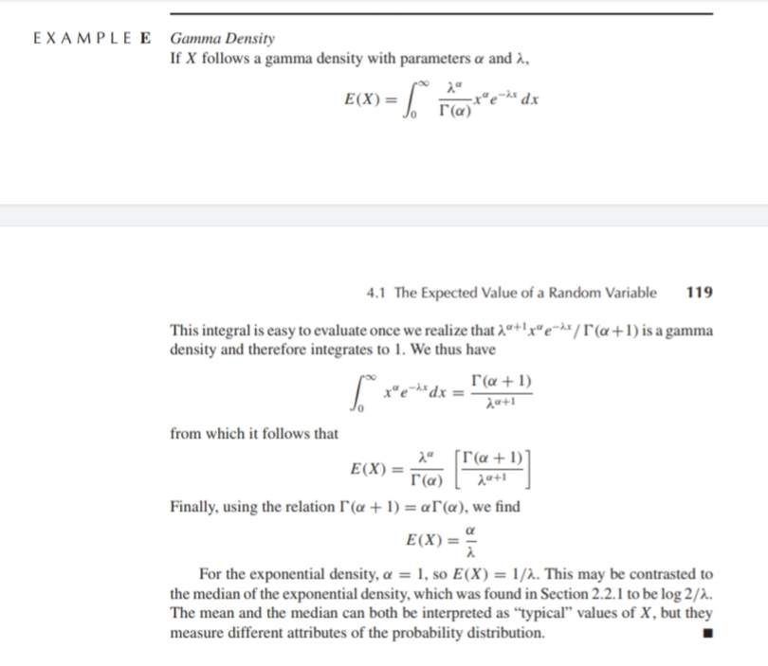

Example 4.1.F – Not Codable (Reason: Theoretical example of explaining concept)

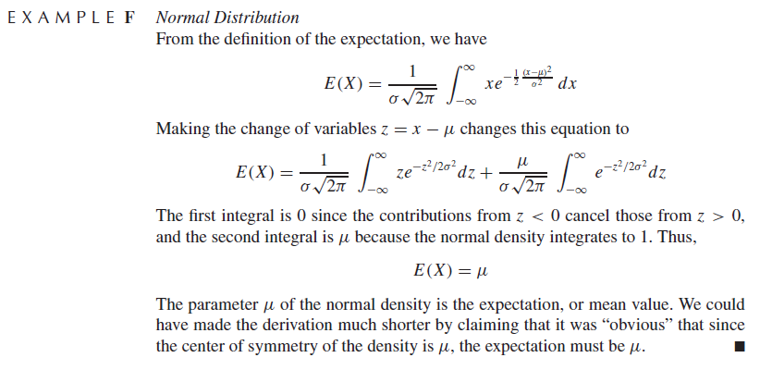

Example 4.1.G – Not Codable (Reason: Infinite computation not possible)

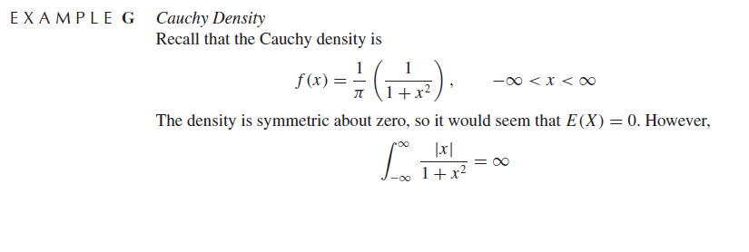

Example 4.1.H – Codable

Example 4.1.1.A – Not Codable (Reason: Theoretical example of finding expression)

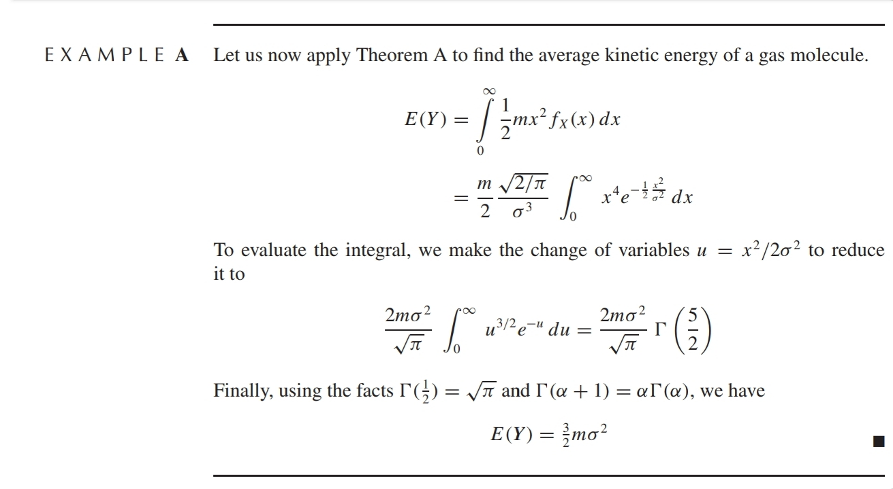

Example 4.1.1.B – Not Codable (Reason: Theoretical example of finding expression)

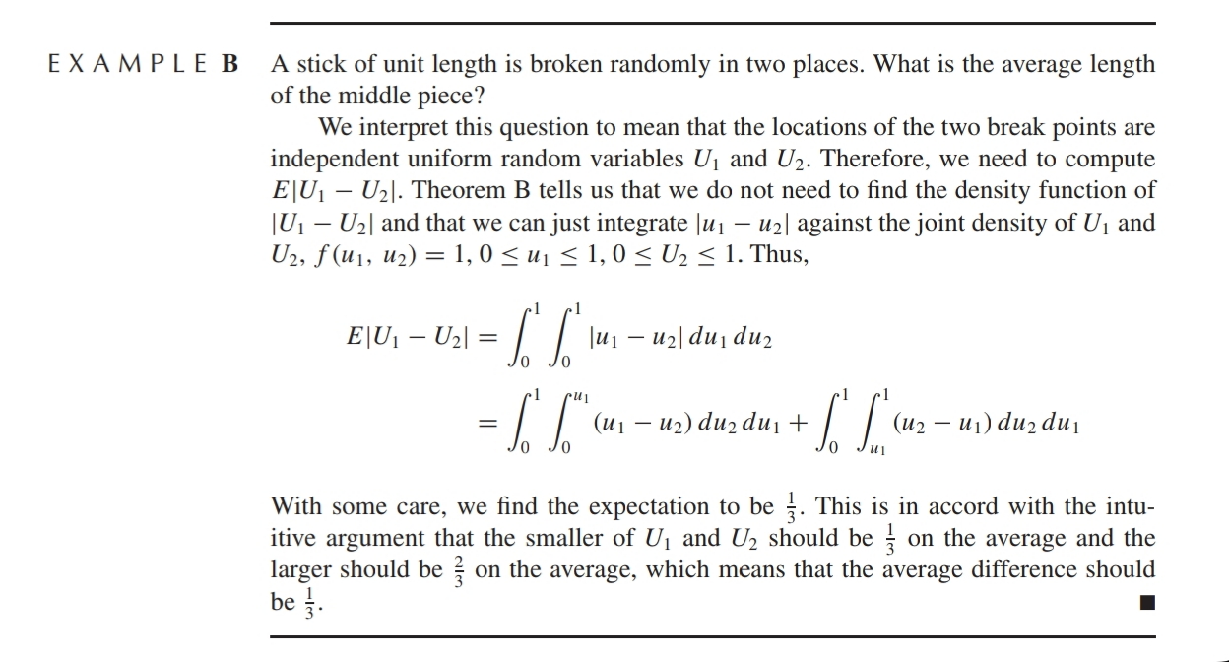

Example 4.1.2.A – Not Codable (Reason: Theoretical example of explaining concept)

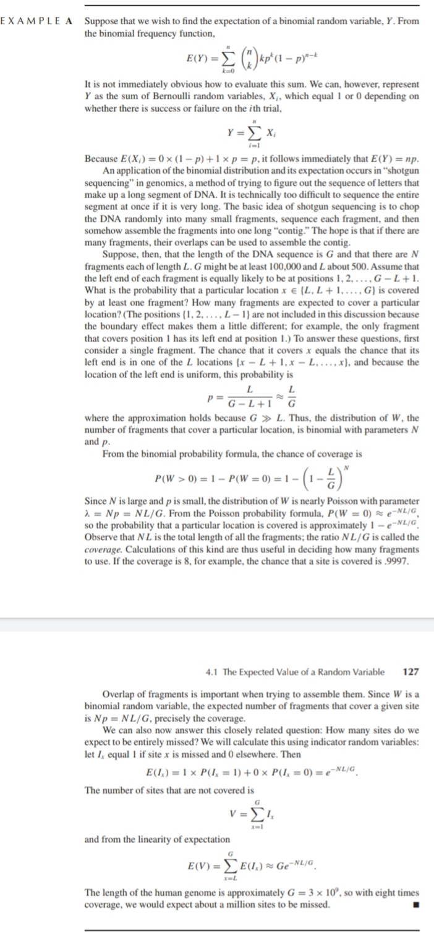

Example 4.1.2.B – Codable

Example 4.1.2.C – Codable

Example 4.1.2.D – Not Codable (Reason: Theoretical example of finding expression)

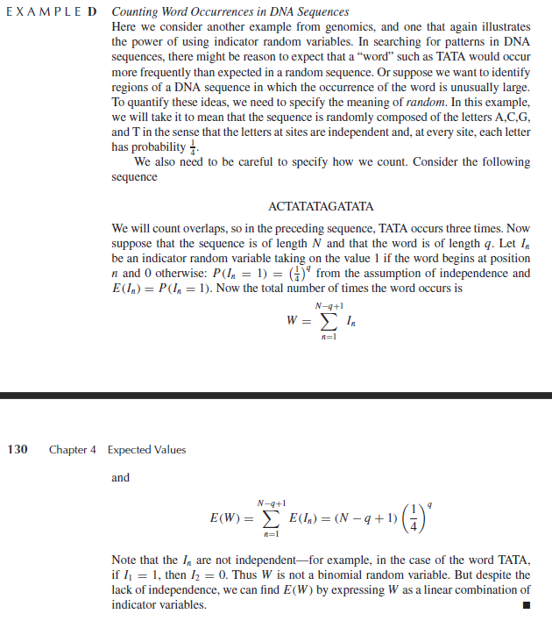

Example 4.1.2.E – Not Codable (Reason: Theoretical example of finding expression)

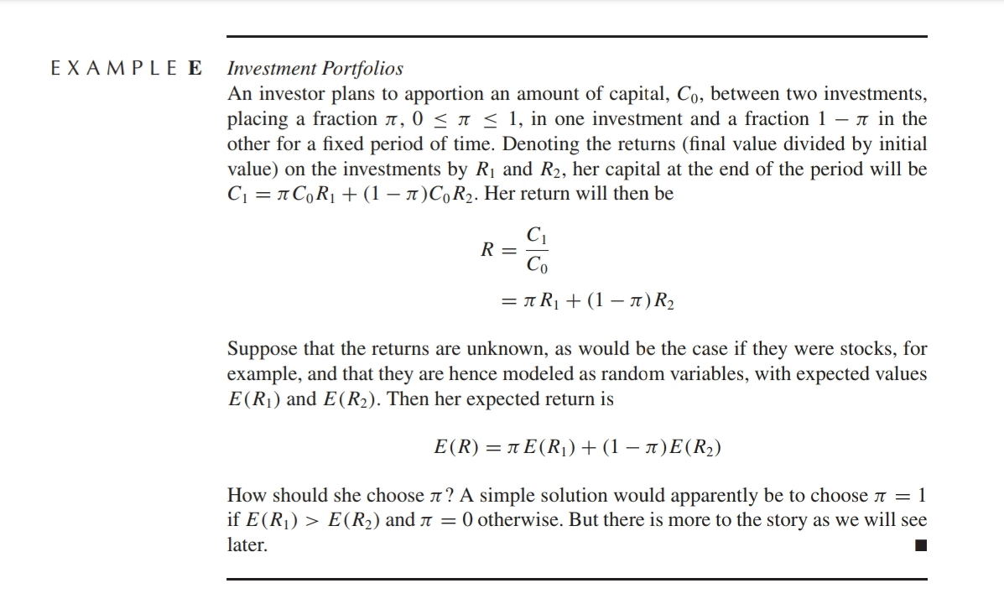

Example 4.2.A – Not Codable (Reason: Theoretical example of finding expression)

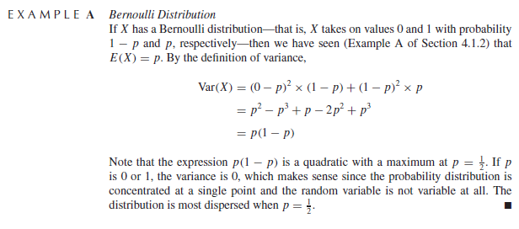

Example 4.2.B – Not Codable (Reason: Theoretical example of finding expression)

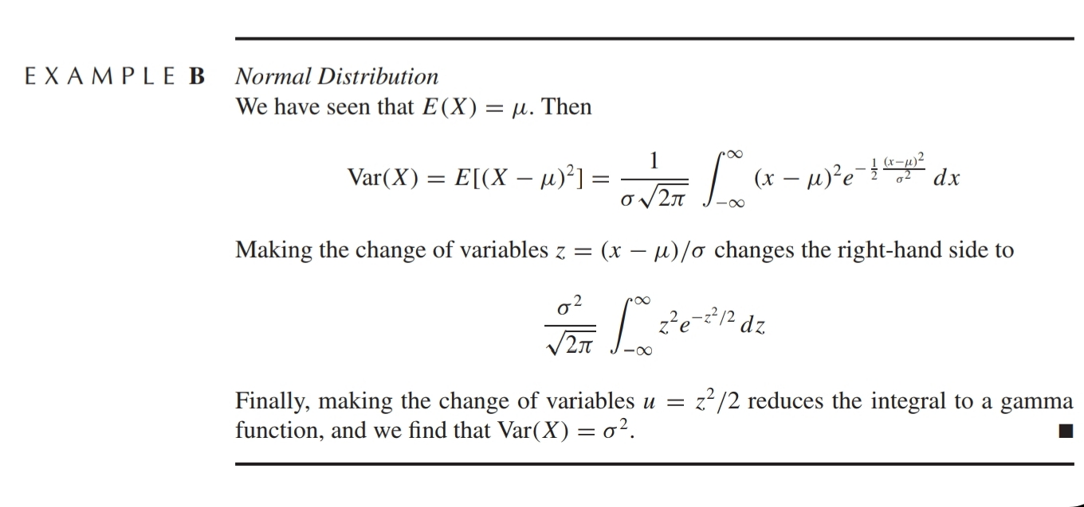

Example 4.2.C – Codable

Example 4.2.D – Not Codable (Reason: Theoretical example of explaining concept)

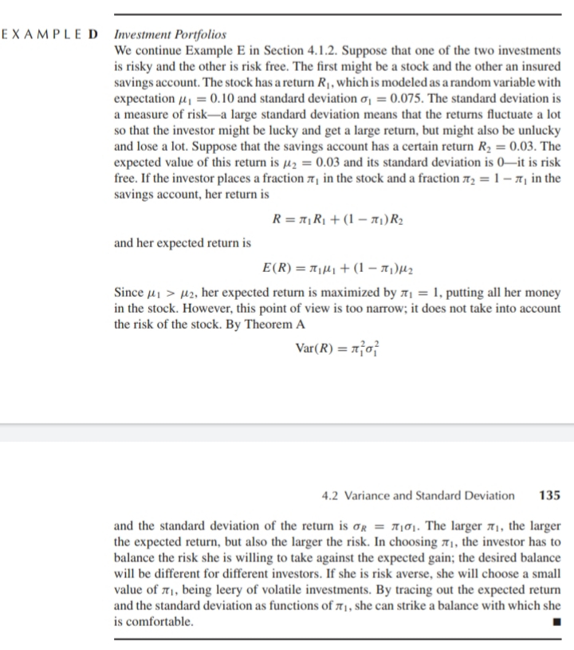

Example 4.2.1.A – Not Codable (Reason: Theoretical example of explaining concept)

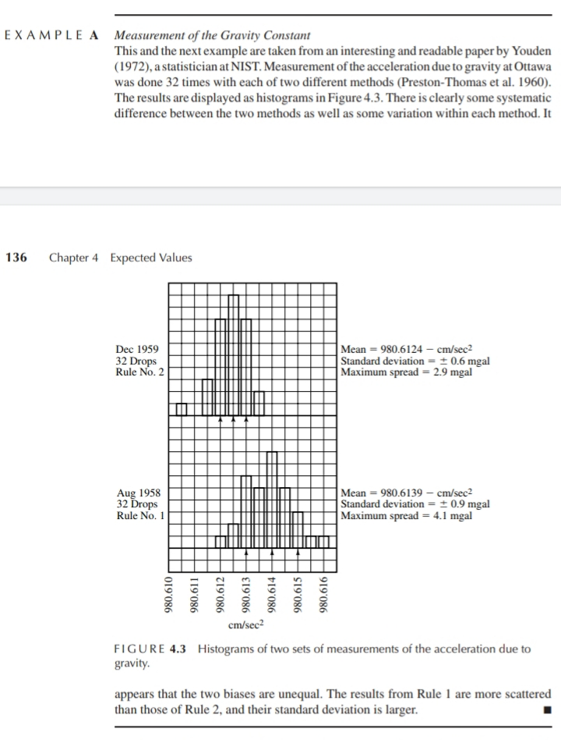

Example 4.2.1.B – Not Codable (Reason: Theoretical example of explaining concept whose data is not available in the book)

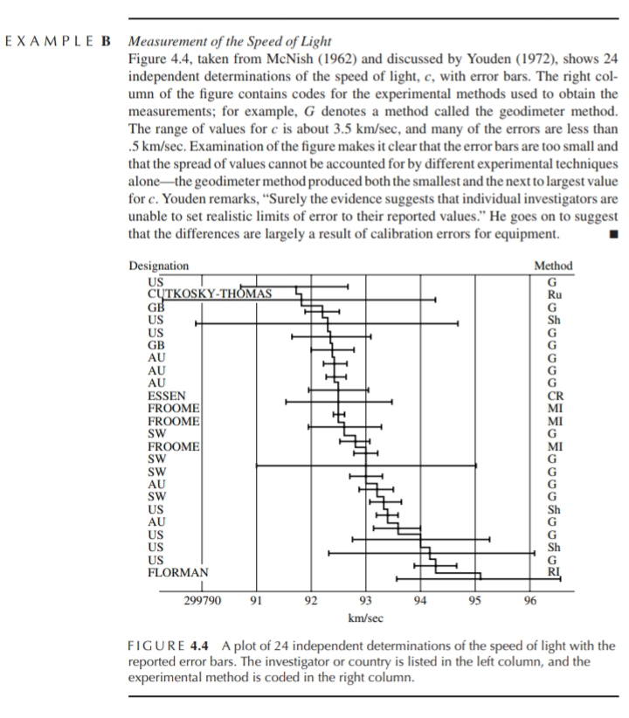

Example 4.3.A – Codable

Example 4.3.B – Not Codable (Reason: Theoretical example of explaining concept)

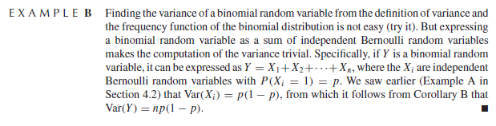

Example 4.3.C – Not Codable (Reason: Theoretical example of explaining concept whose data is not available in the book)

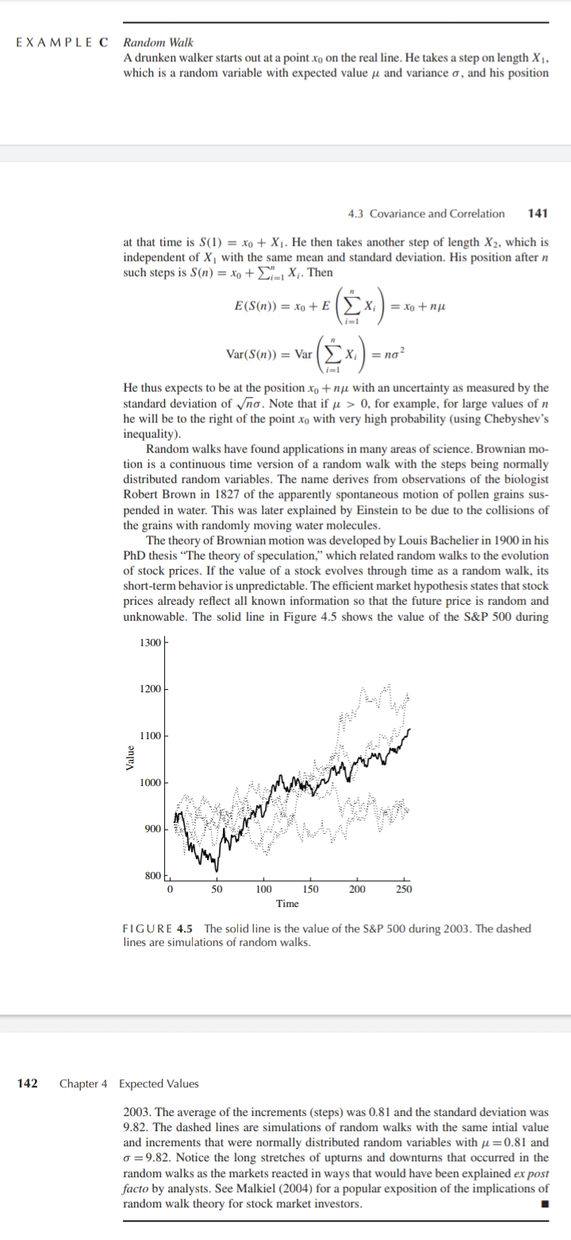

Example 4.3.D – Codable

Example 4.3.E – Not Codable

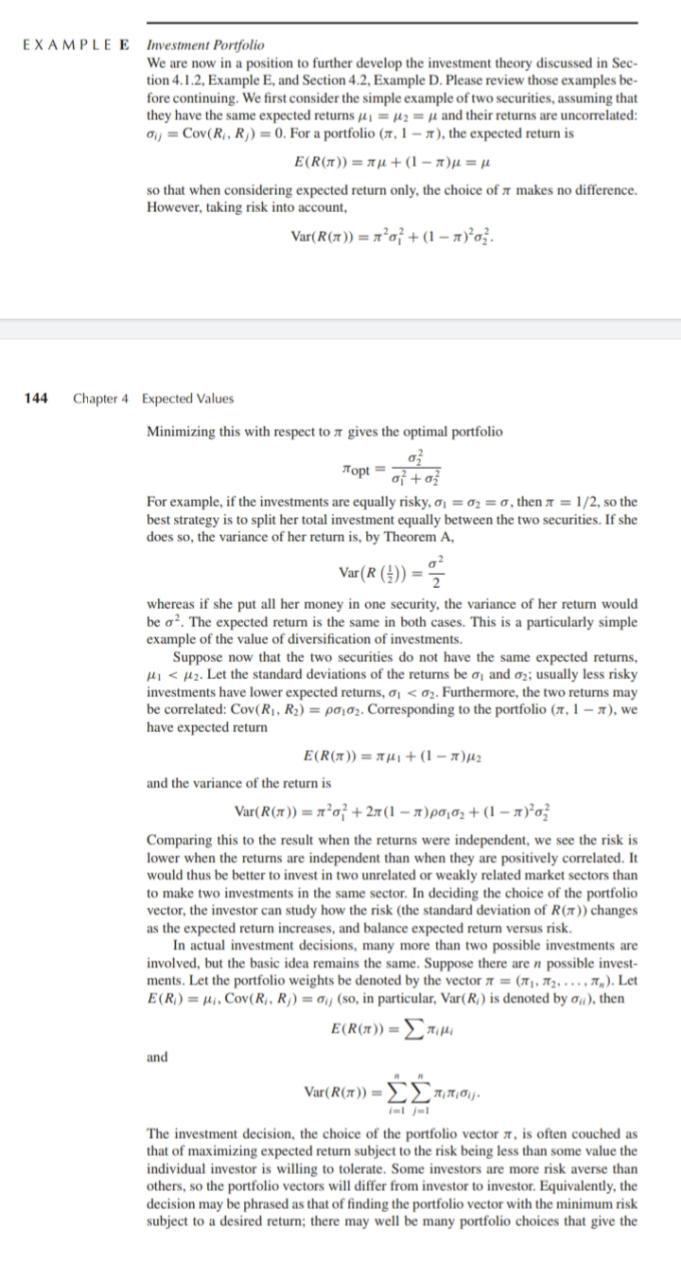

Example 4.3.F – Not Codable (Reason: Theoretical example of explaining concept)

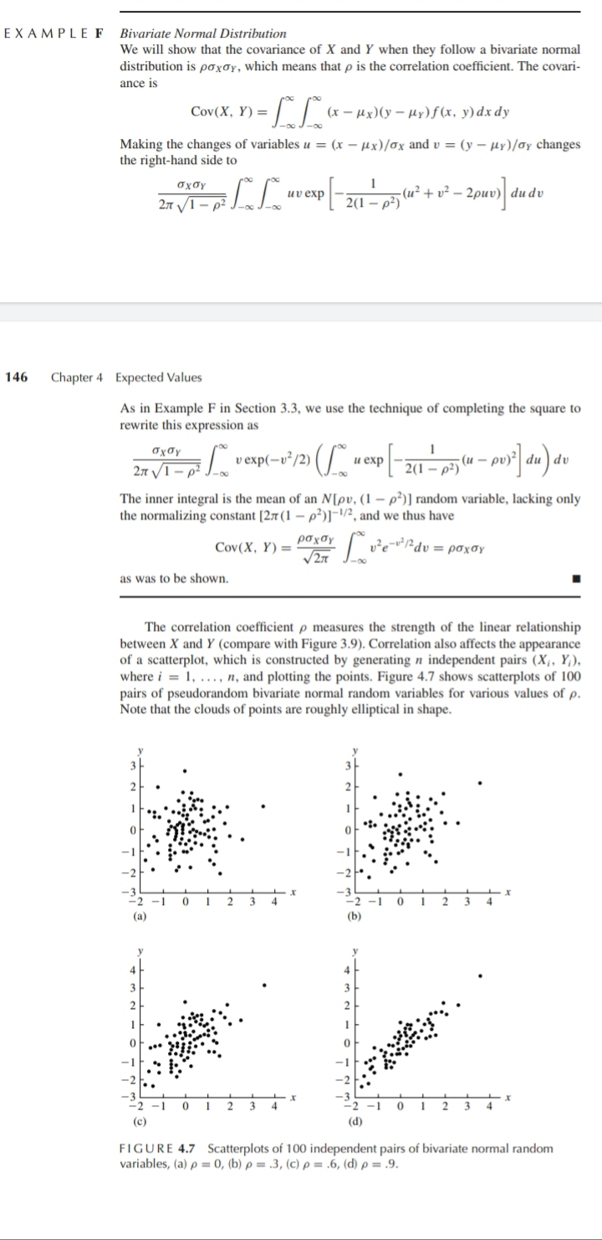

Example 4.4.1.A – Not Codable (Reason: Theoretical example of finding expressions)

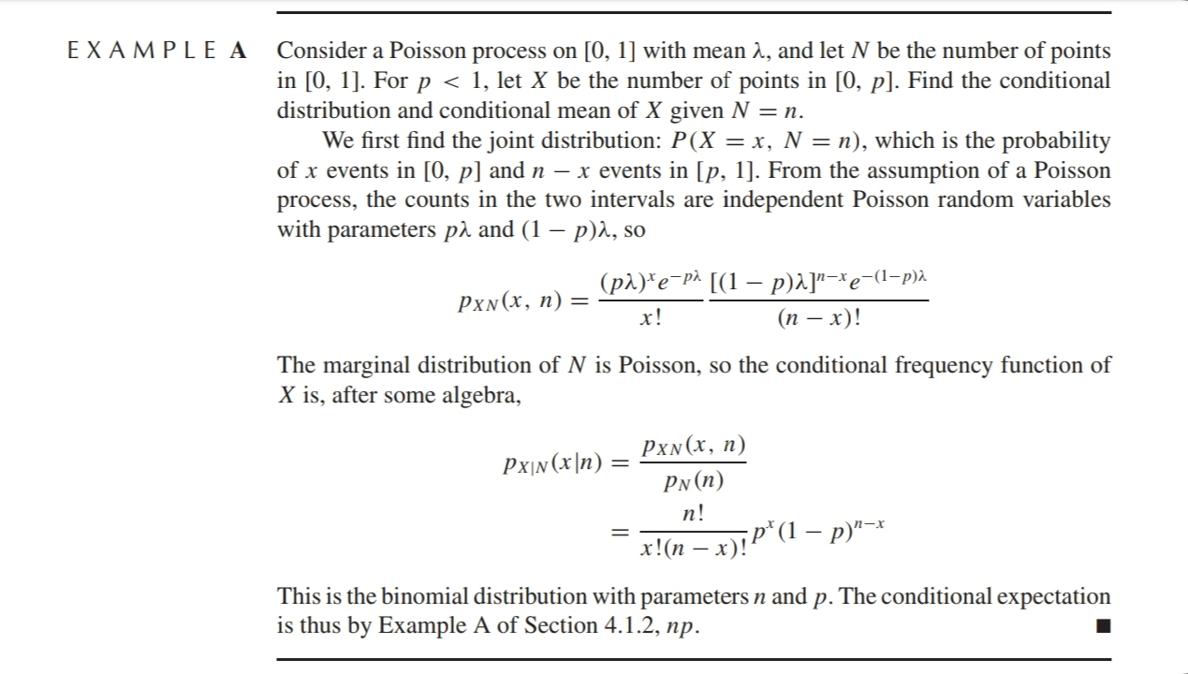

Example 4.4.1.B – Not Codable (Reason: Theoretical example of finding expressions)

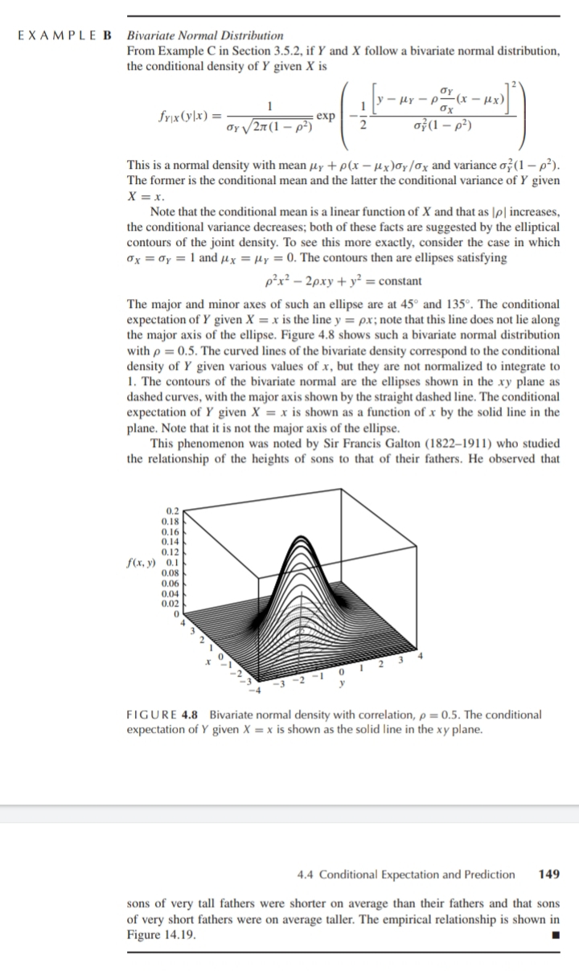

Example 4.4.1.C – Not Codable (Reason: Theoretical example of finding expressions)

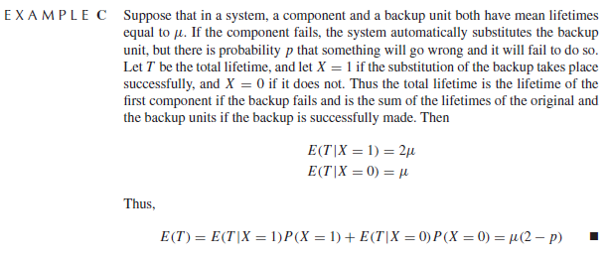

Example 4.4.1.D – Not Codable (Reason: Theoretical example of explaining concept)

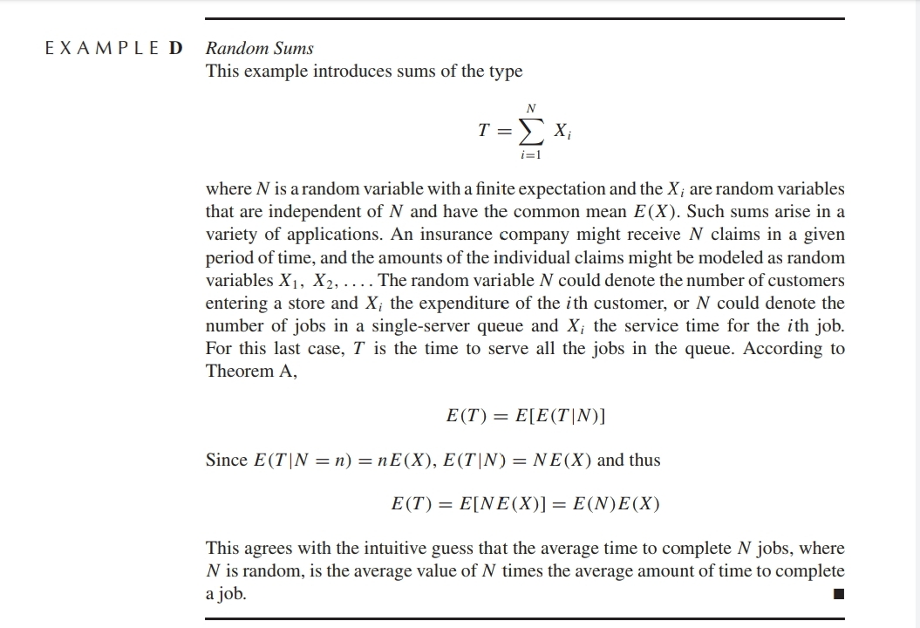

Example 4.4.1.E – Codable

Example 4.4.2.A – Not Codable (Reason: Theoretical example of explaining concept)

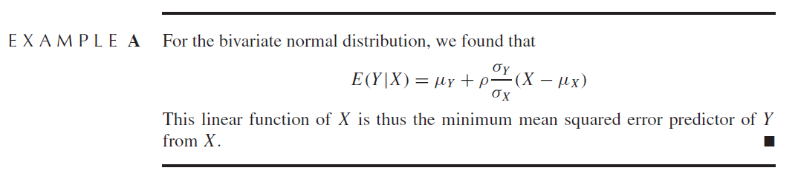

Example 4.4.2.B – Not Codable (Reason: Theoretical example of explaining concept)

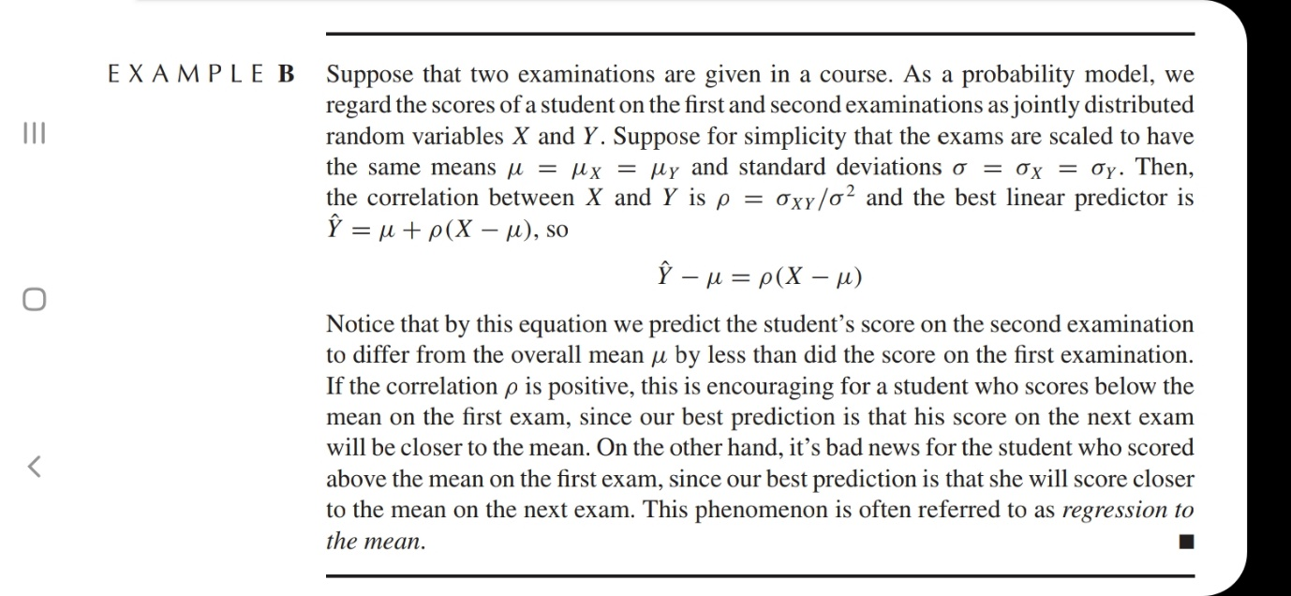

Example 4.5.A – Not Codable (Reason: Theoretical example of finding expressions)

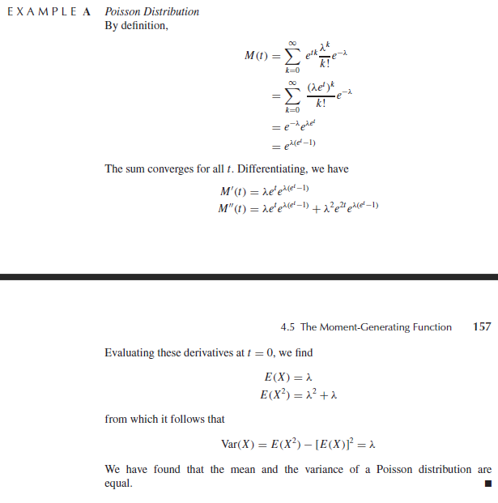

Example 4.5.B – Not Codable (Reason: Theoretical example of finding expressions)

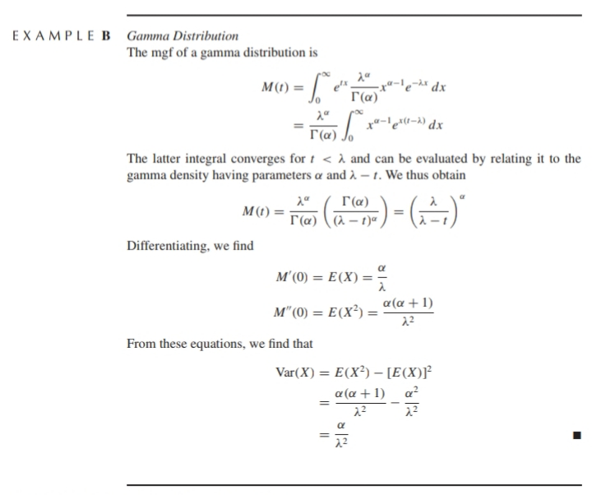

Example 4.5.C – Not Codable (Reason: Theoretical example of finding expressions)

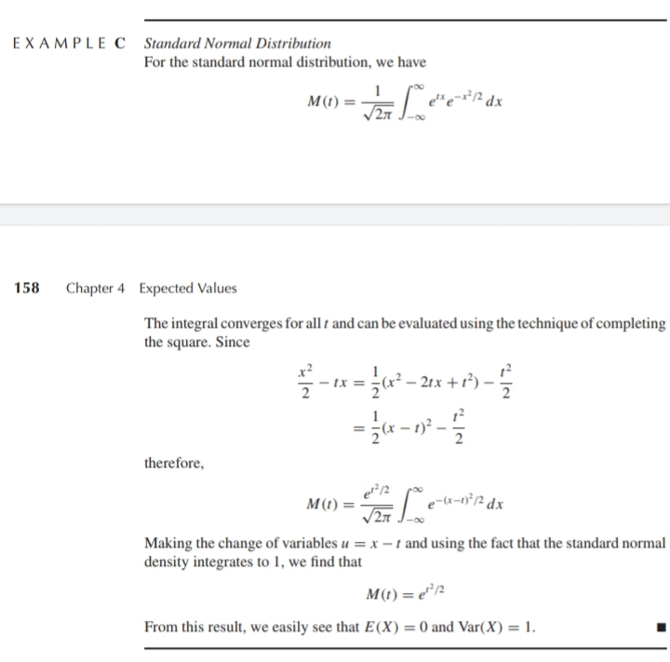

Example 4.5.D – Not Codable (Reason: Theoretical example of finding expressions)

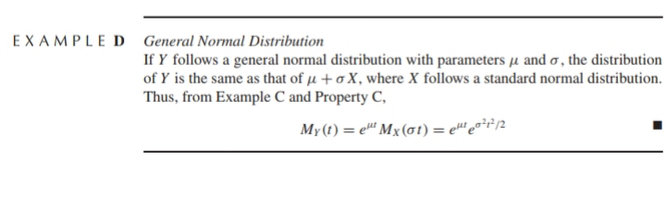

Example 4.5.E – Not Codable (Reason: Theoretical example of finding expressions)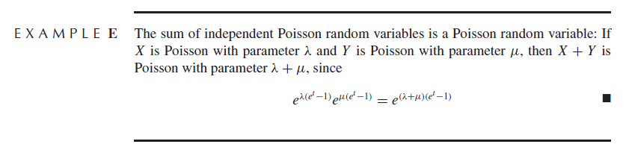

Example 4.5.F – Not Codable (Reason: Theoretical example of finding expressions)

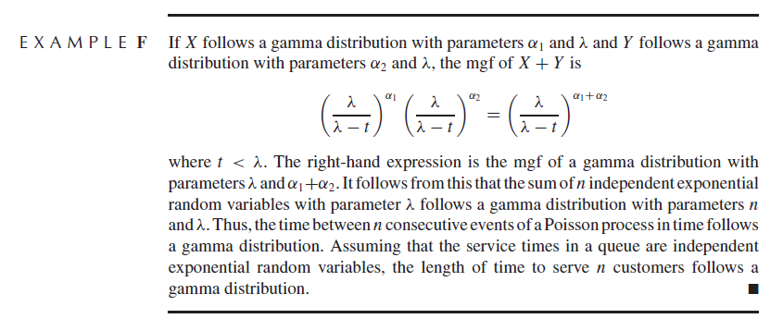

Example 4.5.G – Not Codable (Reason: Theoretical example of finding expressions)

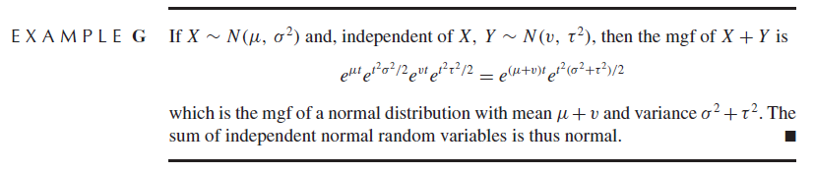

Example 4.5.H – Not Codable (Reason: Theoretical example of finding expressions)

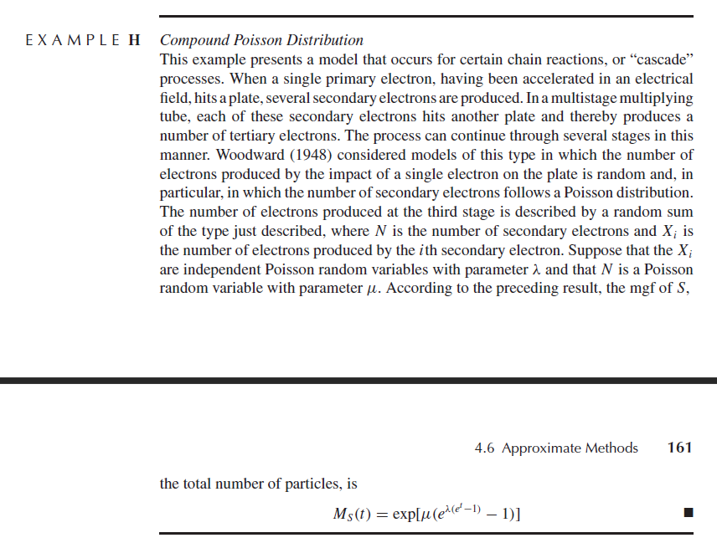

Example 4.6.A – Not Codable (Reason: Theoretical example of finding expressions)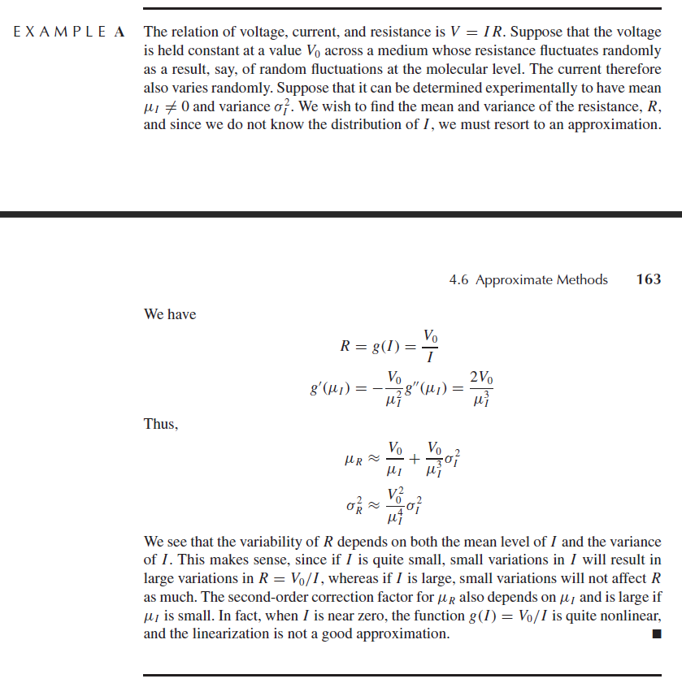

Example 4.6.B – Codable

Example 4.6.C – Not Codable (Reason: Theoretical example of finding expressions)

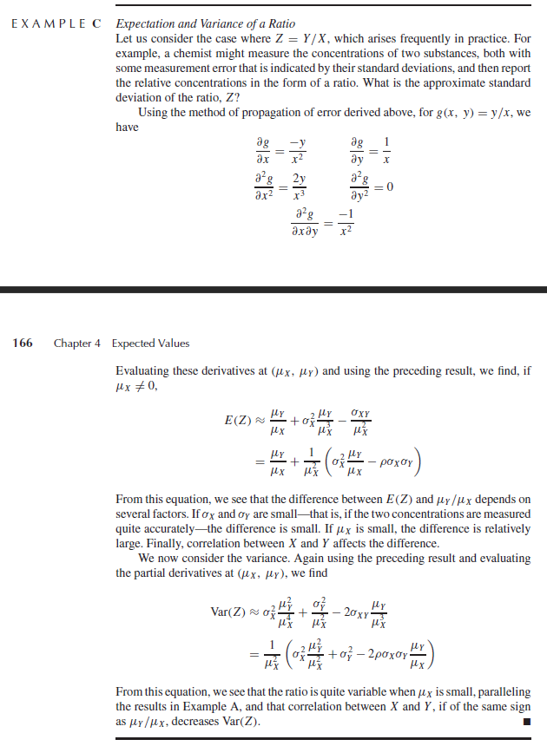

**Chapter 5: Expected Values**

Example 5.2.A – Codable

Example 5.2.B – Not Codable (Reason: Theoretical example of explaining concepts)

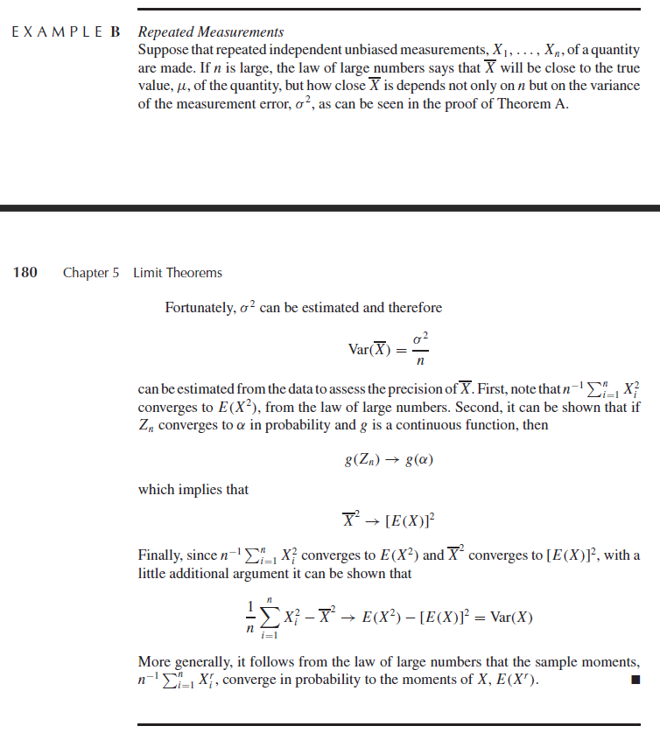

Example 5.2.C – Not Codable (Reason: Theoretical example of explaining concepts)

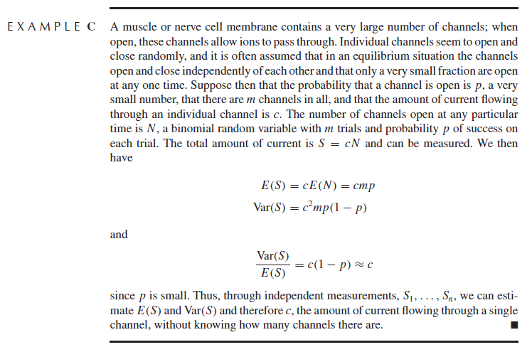

Example 5.3.A – Not Codable (Reason: Theoretical example of explaining concepts)

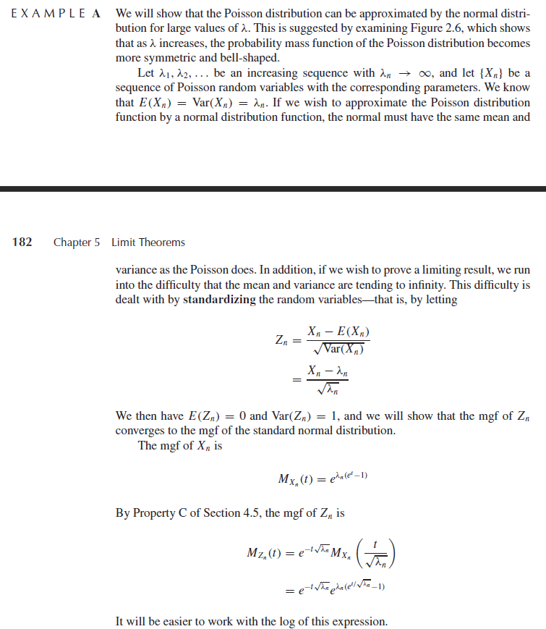

Example 5.3.B – Codable

Example 5.3.C – Codable

Example 5.3.D – Not Codable (Reason: The cdf of gamma distributions doesn’t go negative so false results)

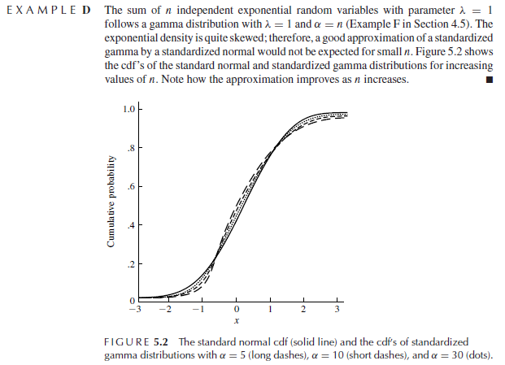

Example 5.3.E – Codable

Example 5.3.F – Codable

Example 5.3.G – Not Codable (Reason: Theoretical example of explaining concepts)

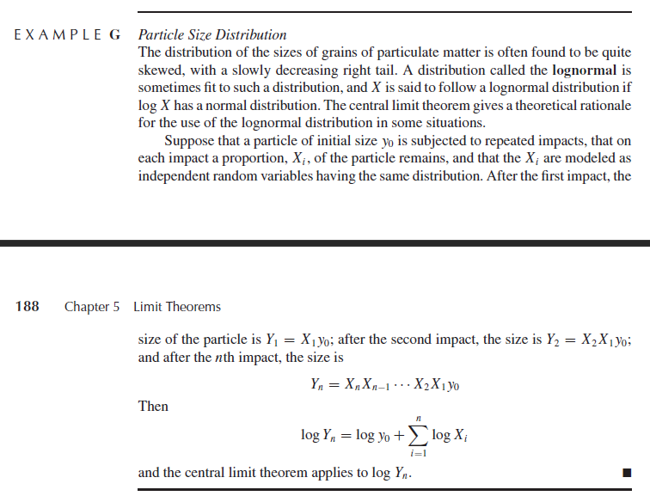

**Chapter 6: Distributions derived from the Normal Distribution**

No examples

**Chapter 7: Survey Sampling**Example 7.2.A – Not Codable (Data not available in the given example)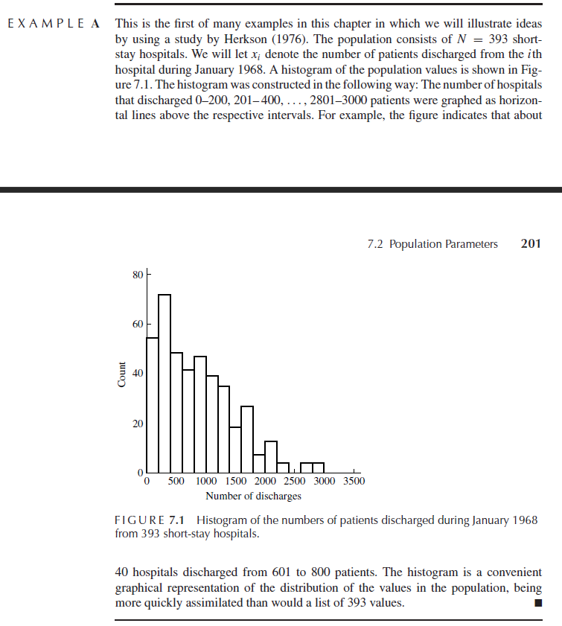

Example 7.3.1.A – Codable

Example 7.3.1.B – Codable

Example 7.3.1.C – Codable

Example 7.3.2.A – Codable

Example 7.3.2.B – Codable

Example 7.3.2.C – Codable

Example 7.3.3.A – Codable

Example 7.3.3.B – Codable

Example 7.3.3.C – Codable

Example 7.3.3.D – Codable

Example 7.3.3.E – Codable

Example 7.4.A – Codable

Example 7.4.B – Not Codable (Reason: Theoretical example of explaining concepts)

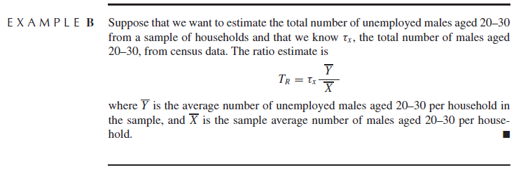

Example 7.4.C – Not Codable (Reason: Theoretical example of explaining concepts)

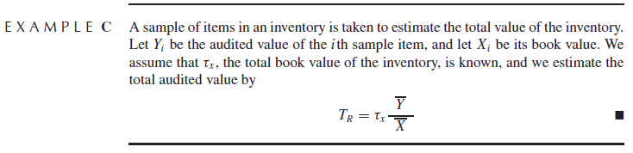

Example 7.4.D – Codable

Example 7.5.2.A – Codable

Example 7.5.2.B – Codable

Example 7.5.3.A – Codable

Example 7.5.3.B – Codable

Example 7.5.3.C – Codable

**Chapter 8: Estimation of Parameters and Fitting of Probability Distributions**

Example 8.3.A – Not Codable (Data not available in the given example)

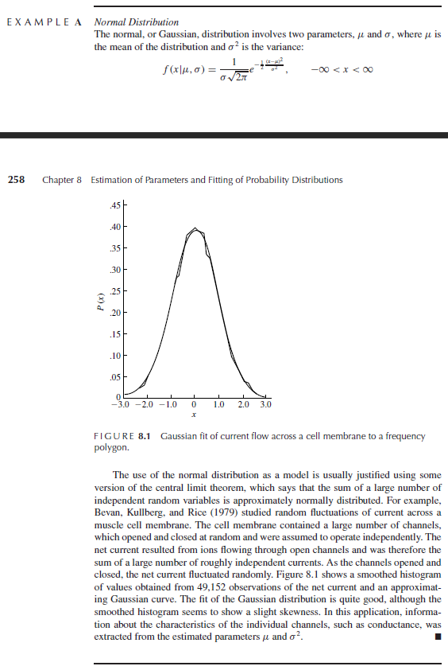

Example 8.3.B – Not Codable (Data not available in the given example)

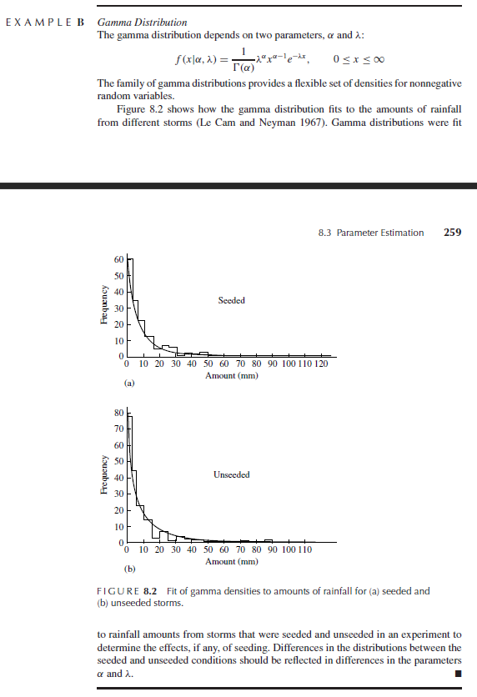

Example 8.4.A – Codable

Example 8.4.B – Not Codable (Reason: Theoretical example of explaining concepts)

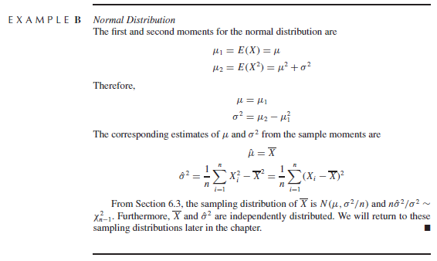

Example 8.4.C – Codable

Example 8.4.D – Codable

Example 8.5.A – Not Codable (Reason: Theoretical example of explaining concepts)

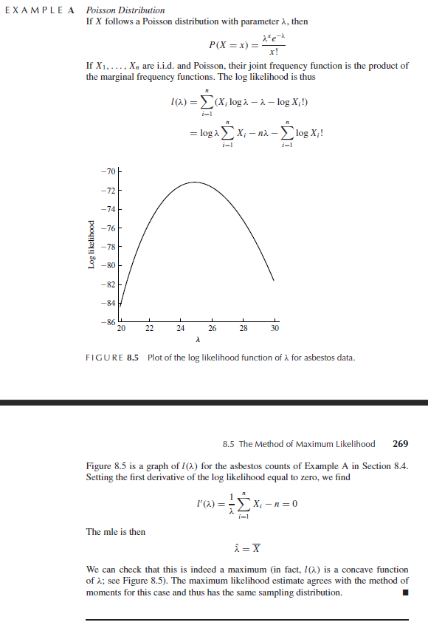

Example 8.5.B – Not Codable (Reason: Theoretical example of explaining concepts)

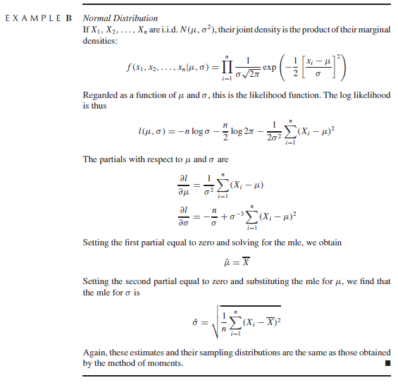

Example 8.5.C – Not Codable (Reason: The simulation may be codable but finding the mle for alpha in gamma distribution is not known to me)

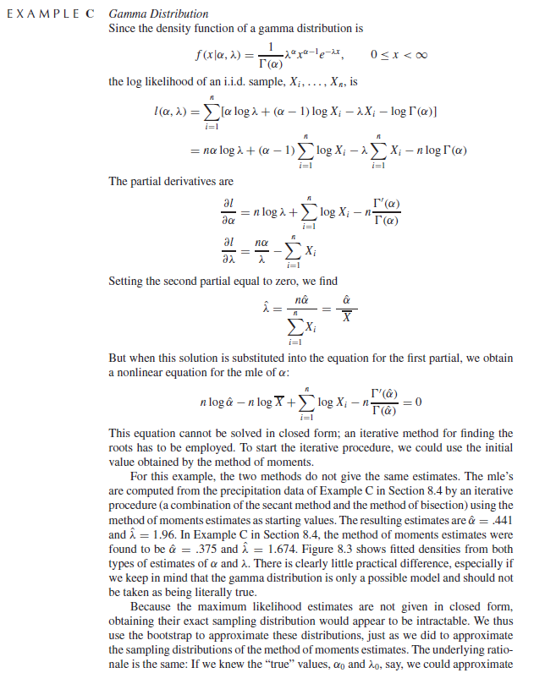

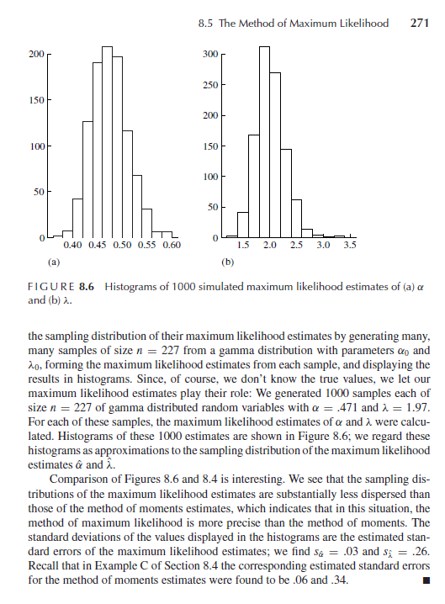

Example 8.5.D – Not Codable (Reason: Theoretical example of explaining concepts)

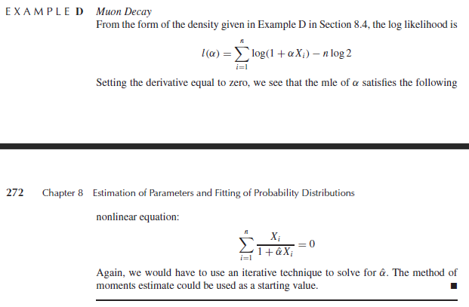

Example 8.5.1.A – Codable

Example 8.5.3.A – Codable

Example 8.5.3.B – Codable

Example 8.5.3.C – Codable

Example 8.5.3.D – Codable

Example 8.5.3.E – Codable

Example 8.6.A – Not Codable (Reason: Theoretical example of explaining concepts)

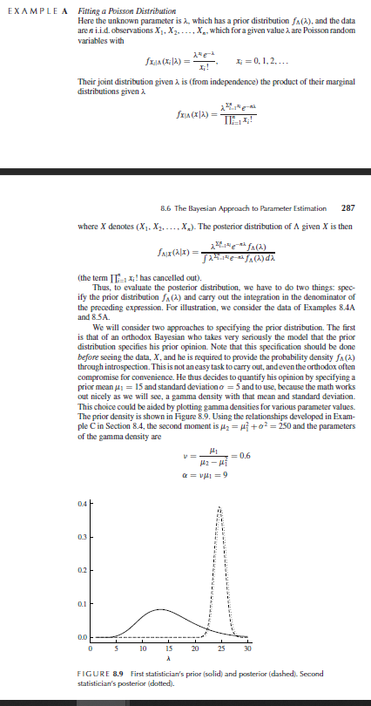

Example 8.6.B – Not Codable (Reason: Theoretical example of explaining concepts)

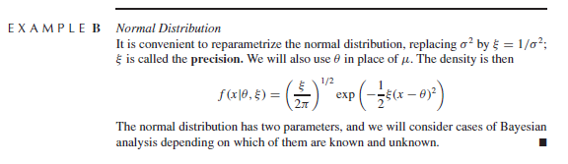

Example 8.6.C – Not Codable (Reason: Theoretical example of explaining concepts)

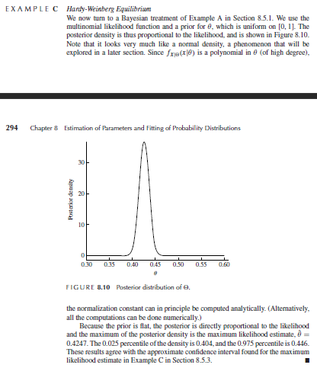

Example 8.7.A – Codable

Example 8.7.B – Not Codable (Reason: Theoretical example of explaining concepts)

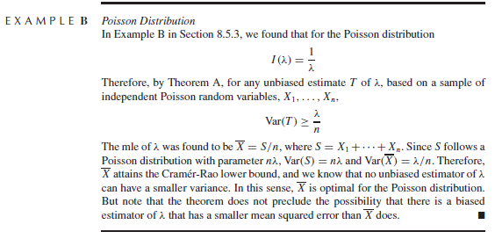

Example 8.7.1.A – Codable

Example 8.8.A – Not Codable (Reason: Theoretical example of explaining concepts)

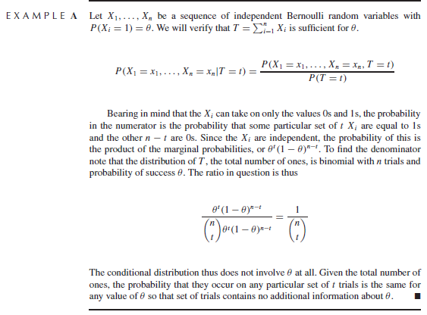

Example 8.8.1.A – Not Codable (Reason: Theoretical example of explaining concepts)

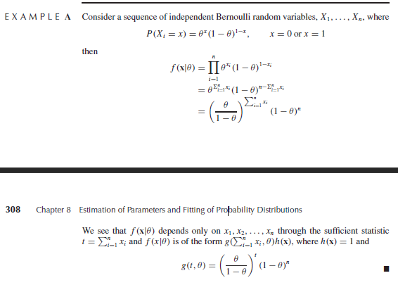

Example 8.8.1.B – Not Codable (Reason: Theoretical example of explaining concepts)

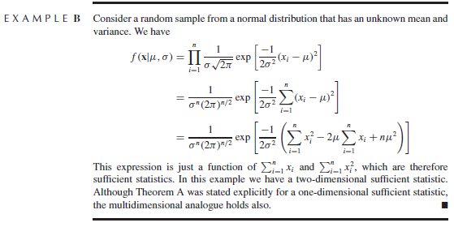

Example 8.8.1.C – Not Codable (Reason: Theoretical example of explaining concepts)

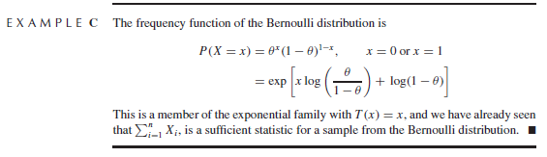

**Chapter 9: Testing Hypothesis and Assessing Goodness of Fit**

Example 9.2.A – Not Codable (Reason: Theoretical example of explaining concepts)

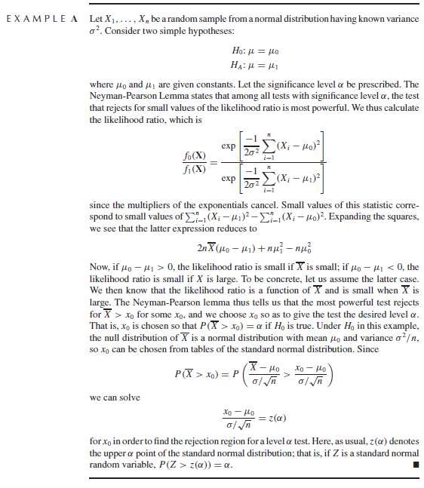

Example 9.2.B – Not Codable (Reason: Theoretical example of explaining concepts)

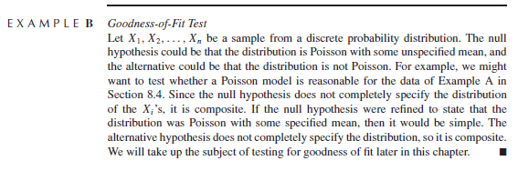

Example 9.2.C – Not Codable (Reason: Theoretical example of explaining concepts)

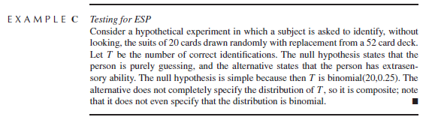

Example 9.2.3.A – Not Codable (Reason: Theoretical example of explaining concepts)

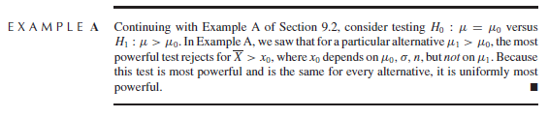

Example 9.3.A – Not Codable (Reason: Theoretical example of explaining concepts)

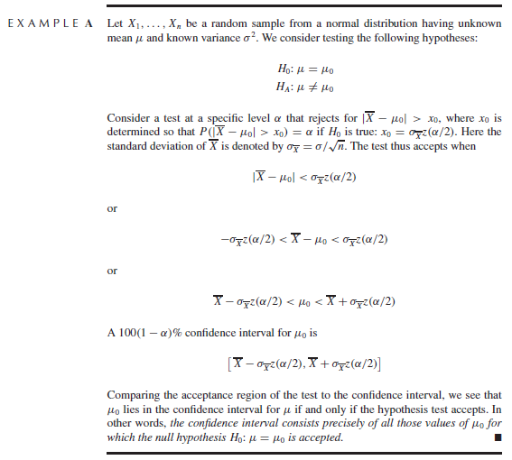

Example 9.4.A – Not Codable (Reason: Theoretical example of explaining concepts)

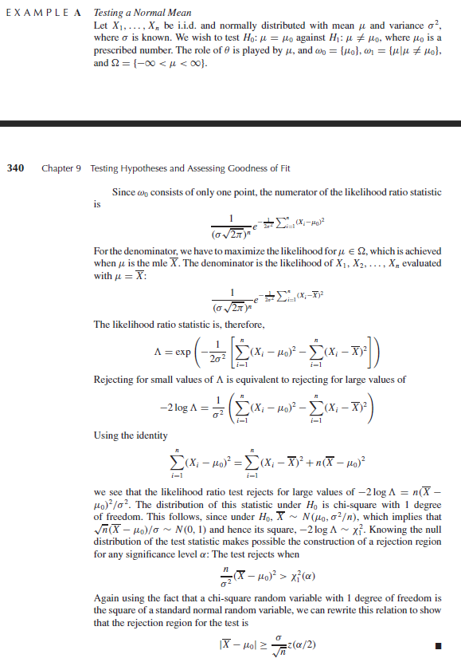

Example 9.5.A – Codable

Example 9.5.B – Codable

Example 9.5.C – Codable

Example 9.6.A – Codable

Example 9.6.B – Codable

Example 9.8.A – Codable

Example 9.8.B – Codable

Example 9.8.C – Codable

Example 9.8.D – Not Codable (Reason: Data not available in the given example)

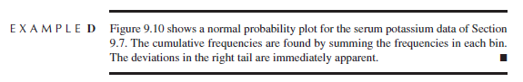

**Chapter 10: Summarizing Data**

Example 10.2.1.A – Codable

Example 10.2.2.A – Codable

Example 10.2.2.B – Codable

Example 10.2.3.A – Not Codable (Reason: Data not available in the given example)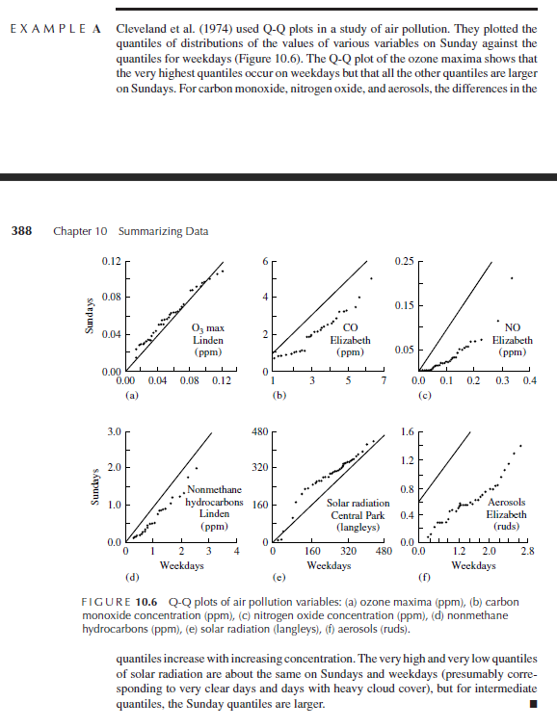

Example 10.2.3.B – Not Codable (Reason: Data not available in the given example)

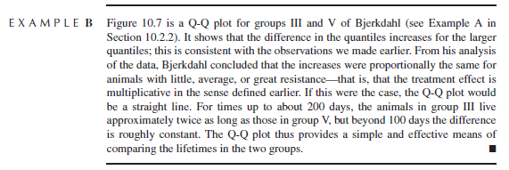

Example 10.4.2.A – Codable

Example 10.4.6.A – Not Codable (Reason: The dataset used is not available in the book)

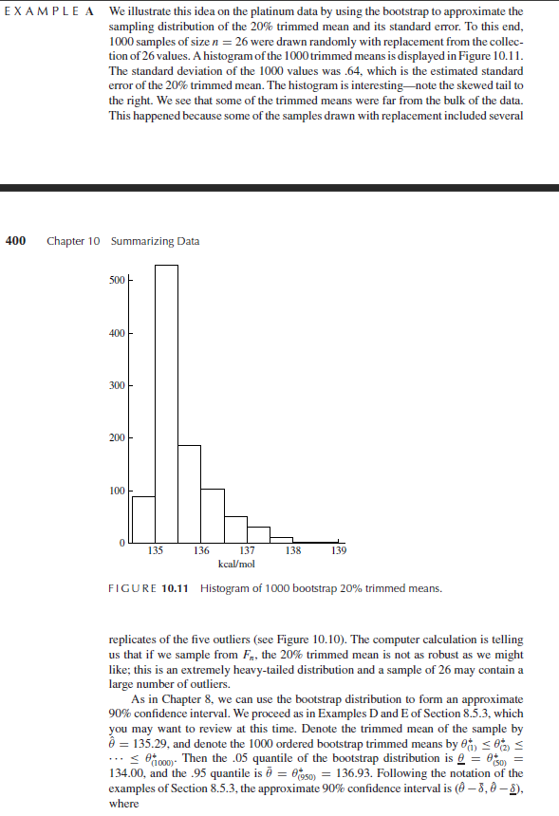

Example 10.6.A – Not Codable (Reason: Data not available in the given example)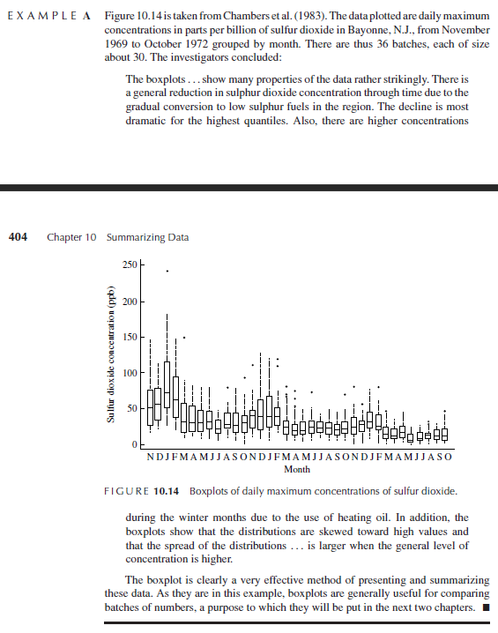

Example 10.7.A – Not Codable (Reason: Data not available in the given example)

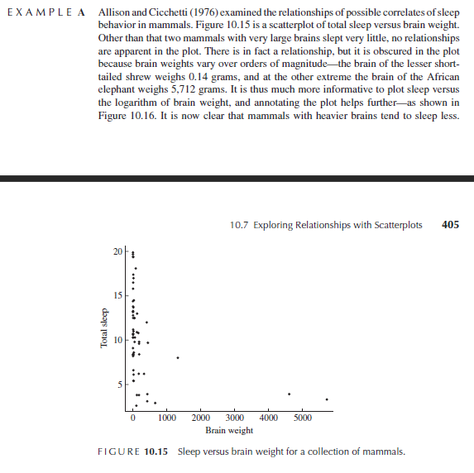

Example 10.7.B– Not Codable (Reason: Data not available in the given example)

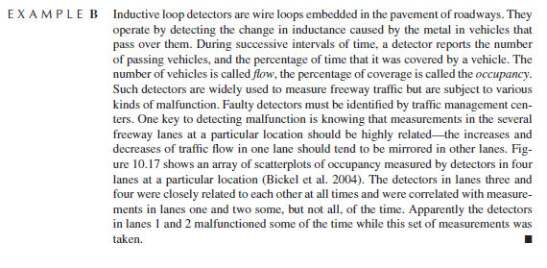

**Chapter 11: Comparing Two Samples**

Example 11.2.1.A– Codable

Example 11.2.1.B – Codable

Example 11.2.1.C – Codable

Example 11.2.2.A – Codable

Example 11.2.3.A – Codable

Example 11.2.3.B – Codable

Example 11.2.3.C – Not Codable (Reason: Data not available in the given example)

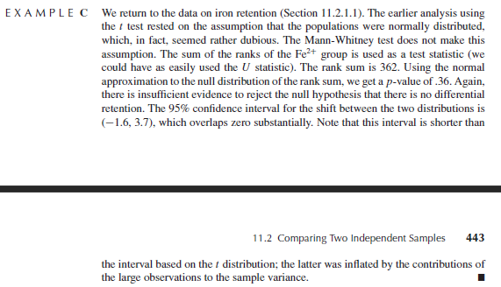

Example 11.3.1.A – Codable

Example 11.3.2.A – Not Codable (Reason: Theoretical example of explaining concepts)

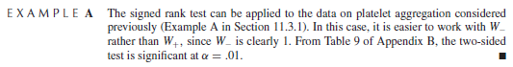

**Chapter 12: The Analysis of Variance**

Example 12.2.1.A – Codable

Example 12.2.2.1.A – Codable

Example 12.2.2.2.A – Not Codable (Reason: Theoretical example of explaining concepts and mainly deals with constructing confidence intervals)

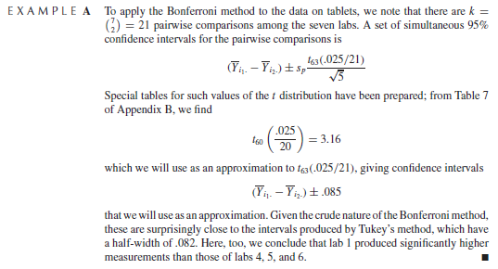

Example 12.2.3.A – Not Codable (Reason: Theoretical example of explaining concepts)

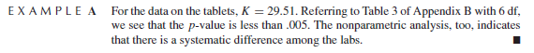

Example 12.3.2.A – Not Codable (Reason: Data not available in the given example)

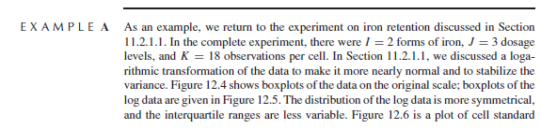

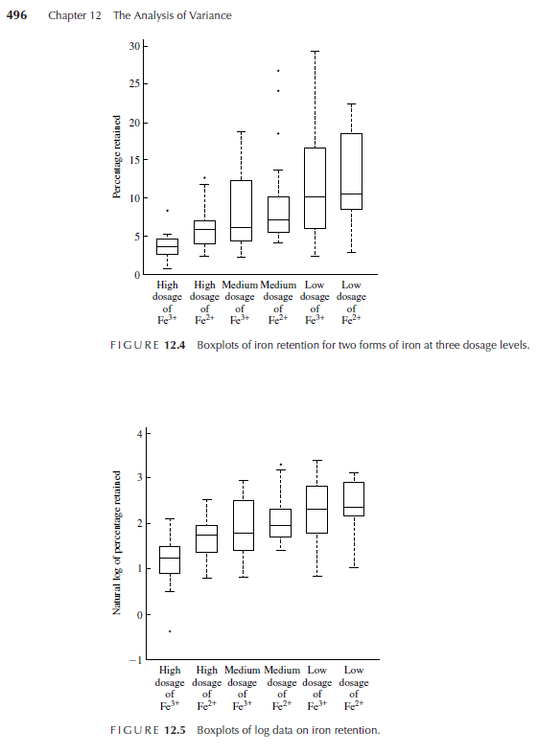

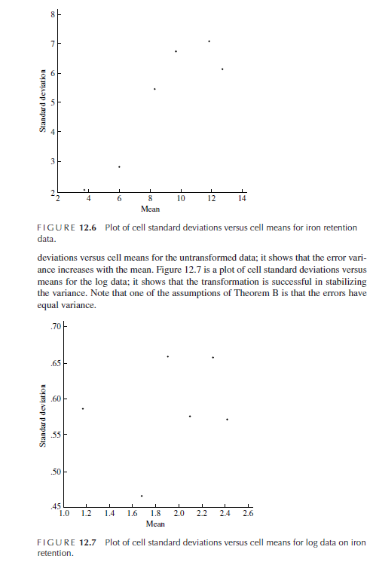

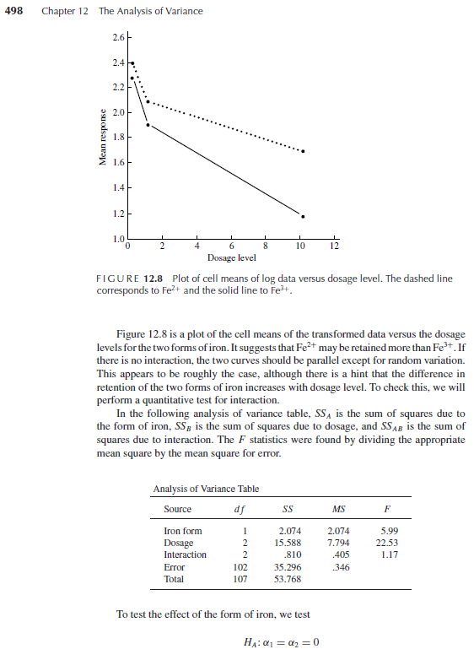

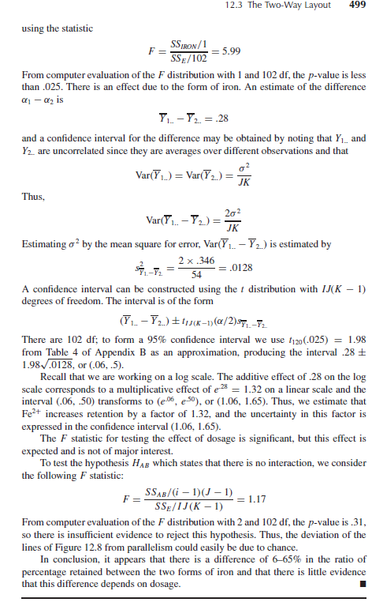

Example 12.3.3.A – Codable

Example 12.3.4.A – Codable

**Chapter 13: The Analysis of Categorical Data (2,1)**

Example 13.5.A – Not Codable (Reason: Data not available in the given example and Theoretical Example)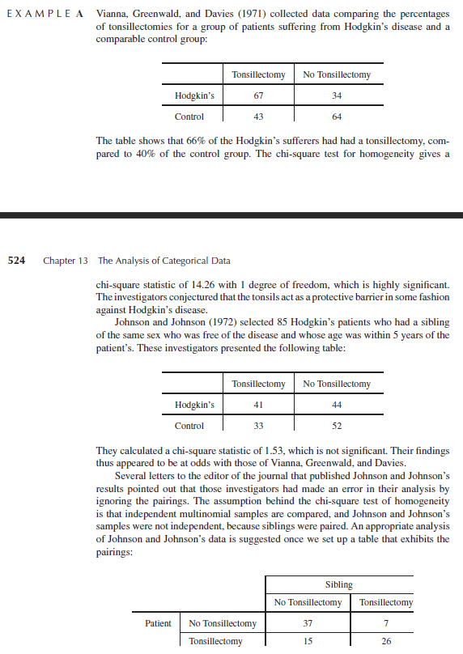

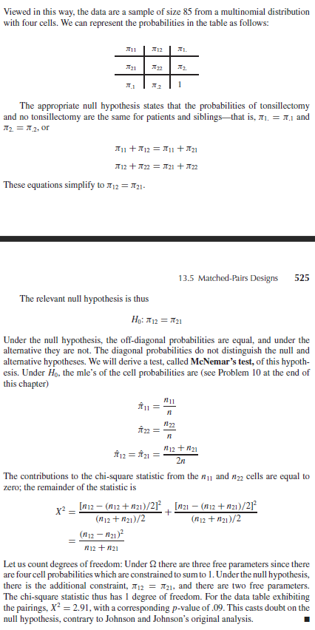

Example 13.5.B – Codable

**Chapter 14: Linear Least Squares**

Example 14.2.1.A – Not Codable (Reason: Data not available in the given example)

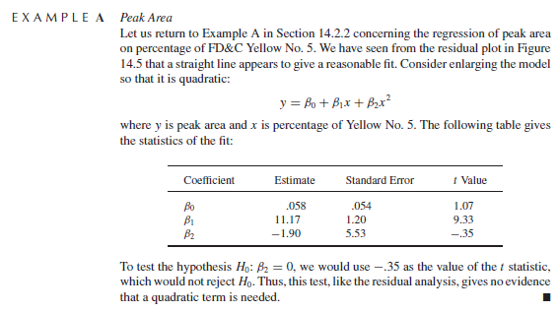

Example 14.2.2.A – Not Codable (Reason: Data not available in the given example)

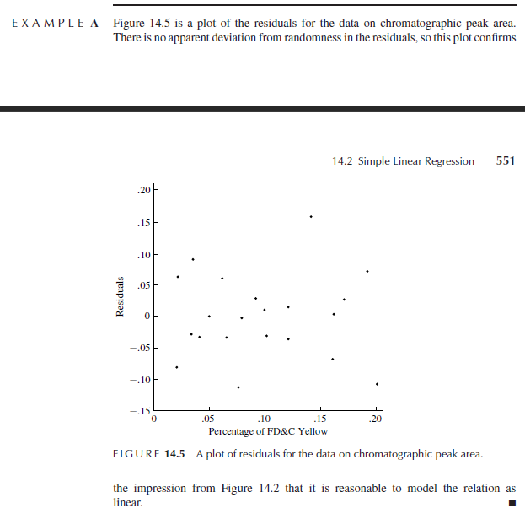

Example 14.2.2.B – Codable

Example 14.2.2.C – Not Codable (Reason: Data not available in the given example)

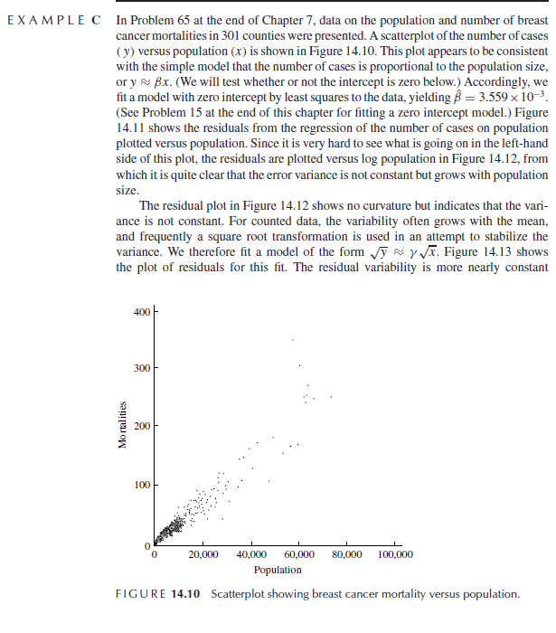

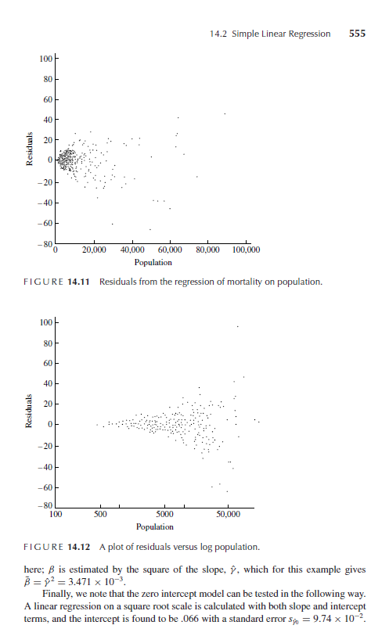

Example 14.2.2.D – Not Codable (Reason: Theoretical example of explaining concepts)

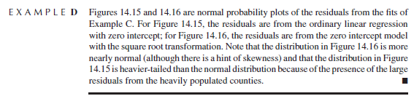

Example 14.2.2.E – Codable

Example 14.2.3.A – Not Codable (Reason: Data not available in the given example)

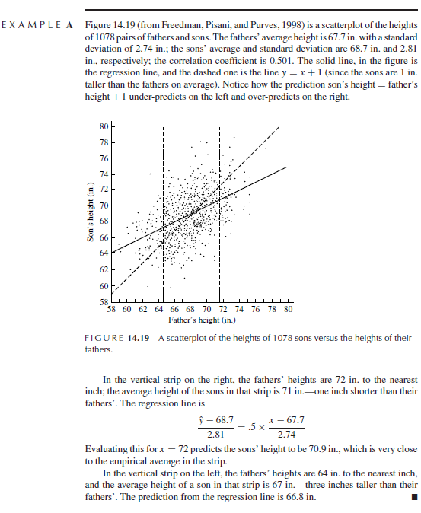

Example 14.2.3.B – Not Codable (Reason: Data not available in the given example)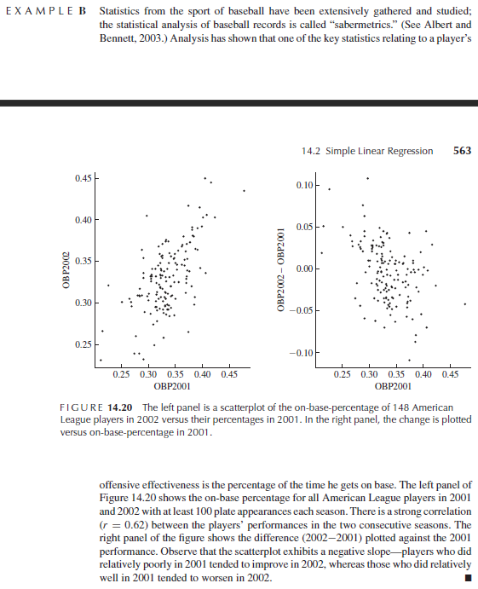

Example 14.3.A – Not Codable (Reason: Theoretical example of explaining concepts)

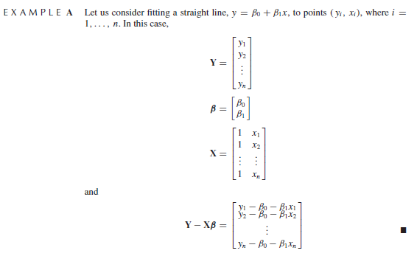

Example 14.3.B – Not Codable (Reason: Theoretical example of explaining concepts)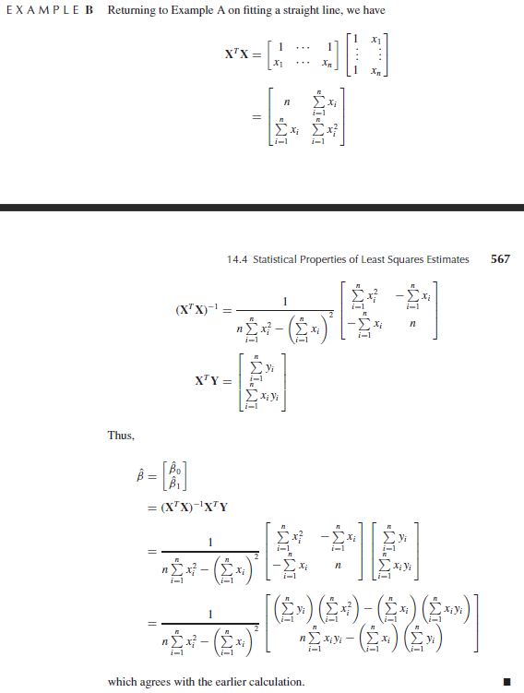

Example 14.4.1.A – Not Codable (Reason: Theoretical example of explaining concepts) 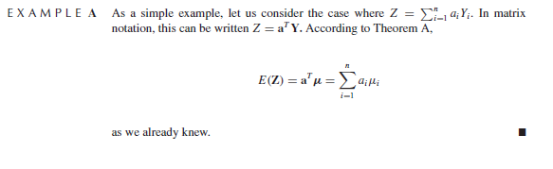

Example 14.4.1.B – Not Codable (Reason: Theoretical example of explaining concepts)

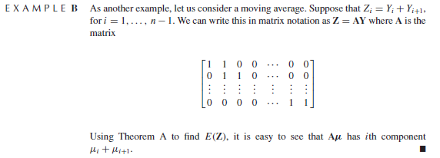

Example 14.4.1.C – Not Codable (Reason: Theoretical example of explaining concepts)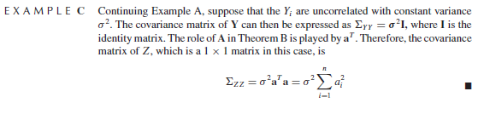

Example 14.4.1.D – Not Codable (Reason: Theoretical example of explaining concepts)

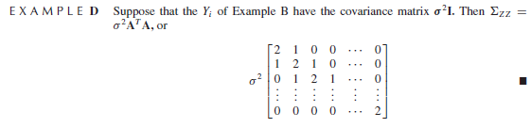

Example 14.4.1.E – Not Codable (Reason: Theoretical example of explaining concepts)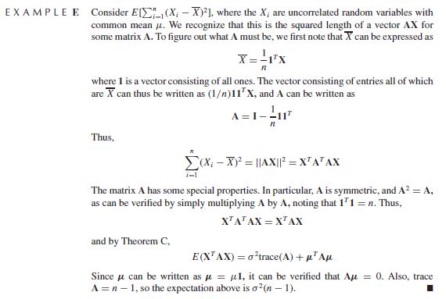

Example 14.4.1.F – Not Codable (Reason: Theoretical example of explaining concepts)

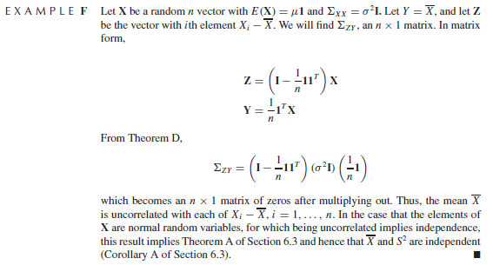

Example 14.4.2.A – Not Codable (Reason: Theoretical example of explaining concepts)

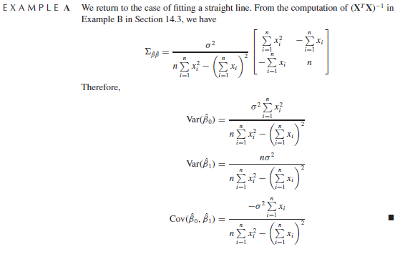

Example 14.4.5.A – Not Codable (Reason: Data not available in the given example)

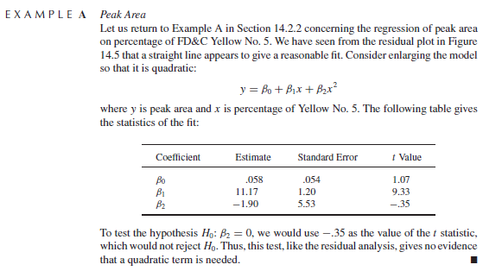

Example 14.4.5.B – Codable